

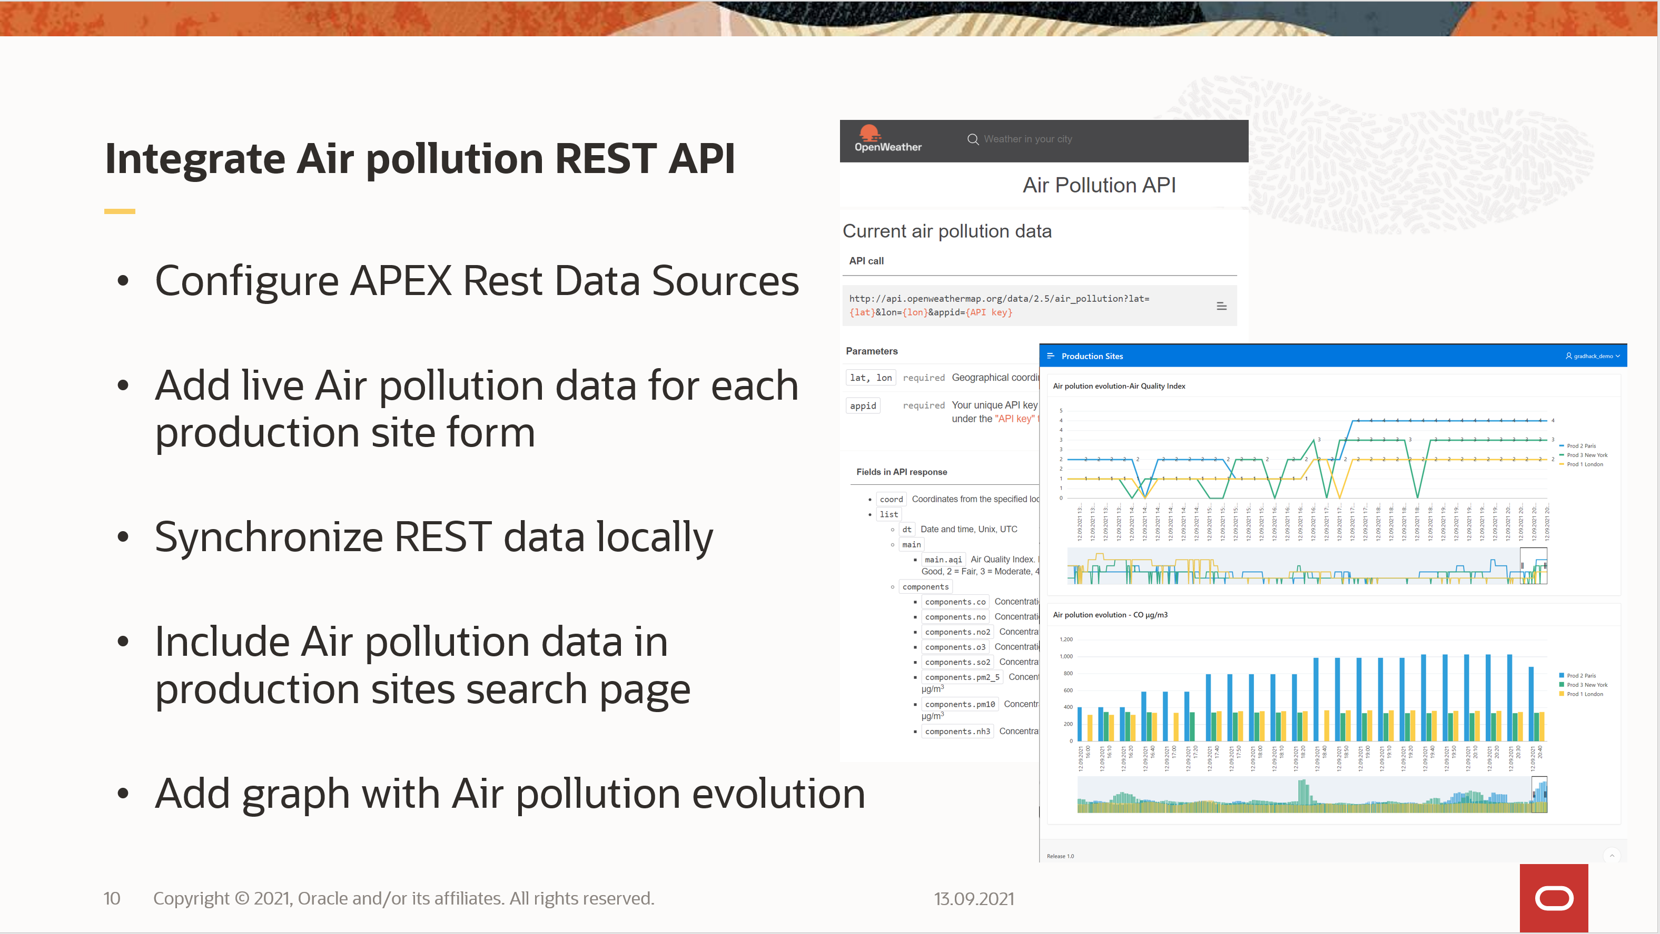

Author: Daniel Ivanescu

API reference : https://openweathermap.org/api/air-pollution

**APEX Configure REST Data Sources**  
Steps:

1. Open your Production Sites application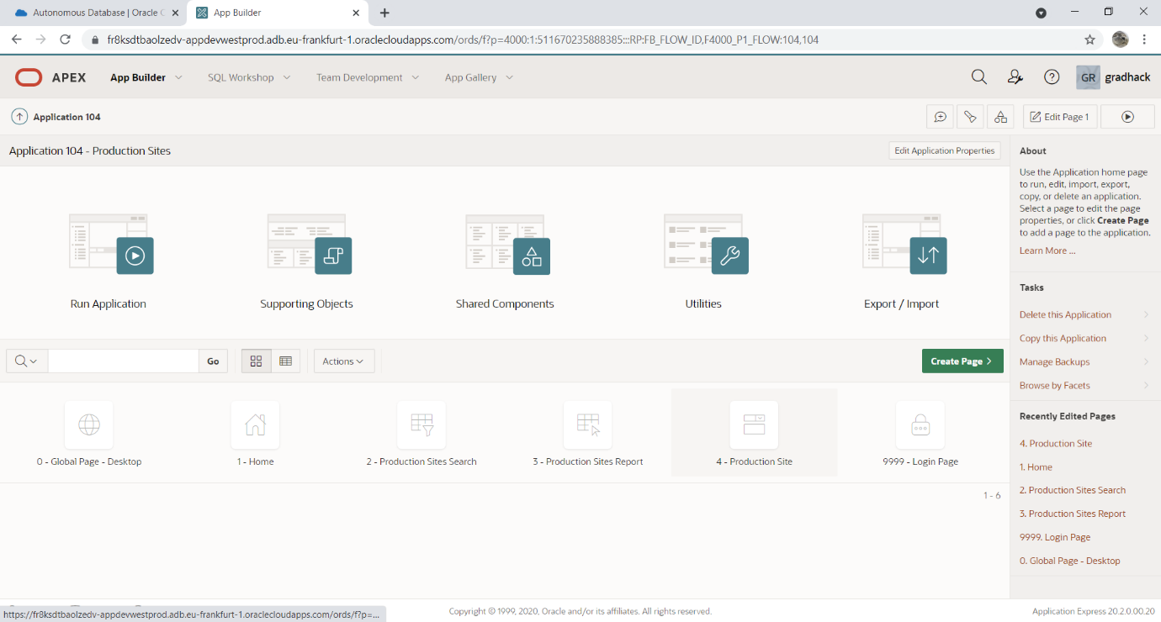
2. Navigate to Shared components > Rest Data Sources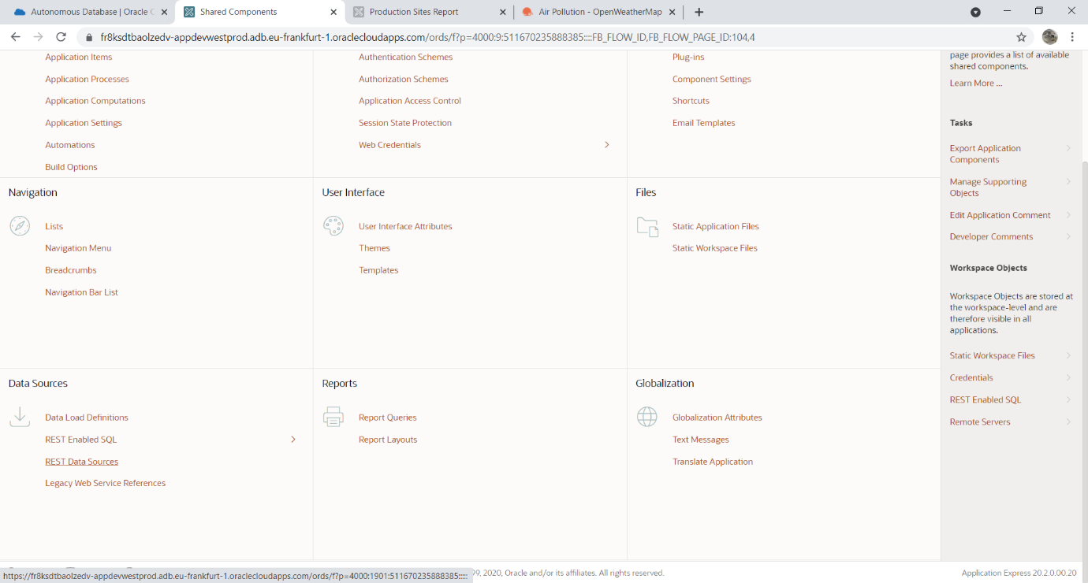
3. - Click “Create”  
   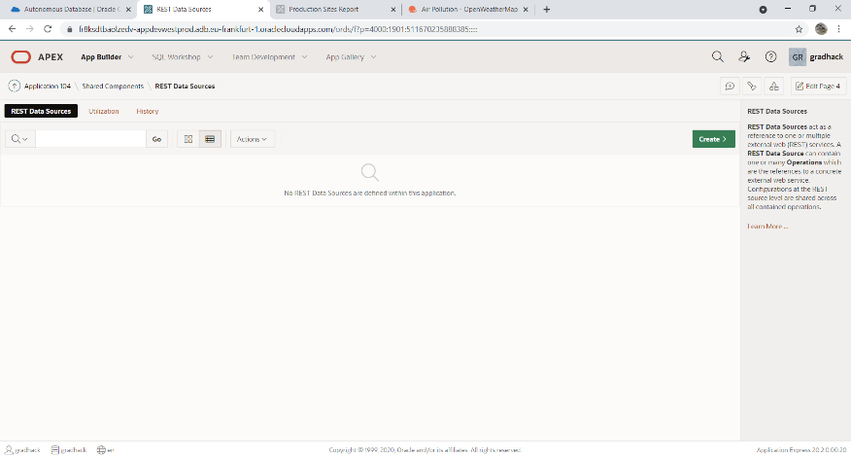
4. Select “From scratch”   
   - Click “Next”  
   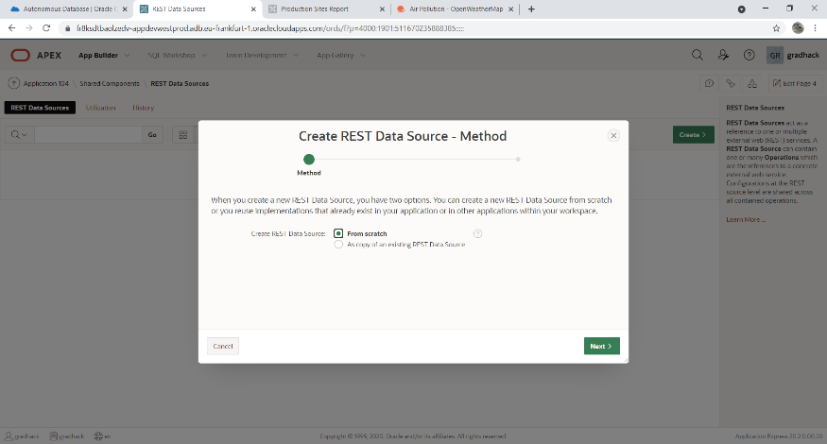
5. General details:  
   - REST Data Source Type: Simple HTTP  
   - Name : air_polution  
   - URL Endpoint : https://api.openweathermap.org/data/2.5/air_pollution  
   *notice the API URL from the website is using given as HTTP. APEX requires HTTPS and this is supported by the API.  
   - Click “Next”  
   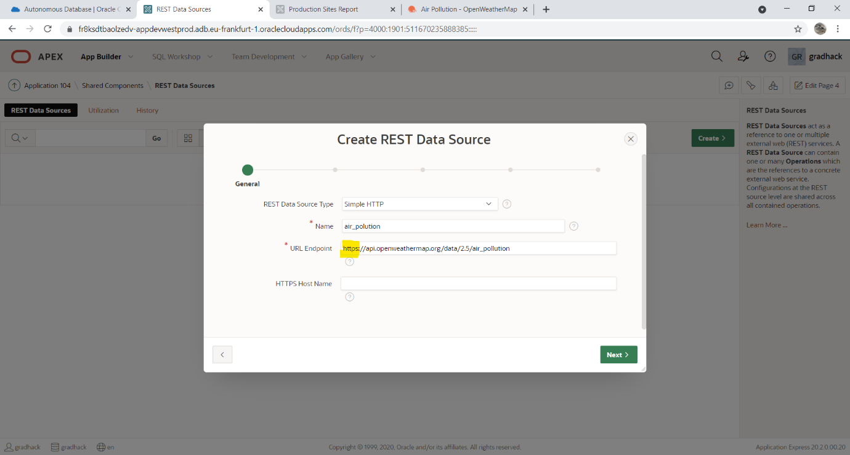
6. Remote server:  
   - Click “Next”  
   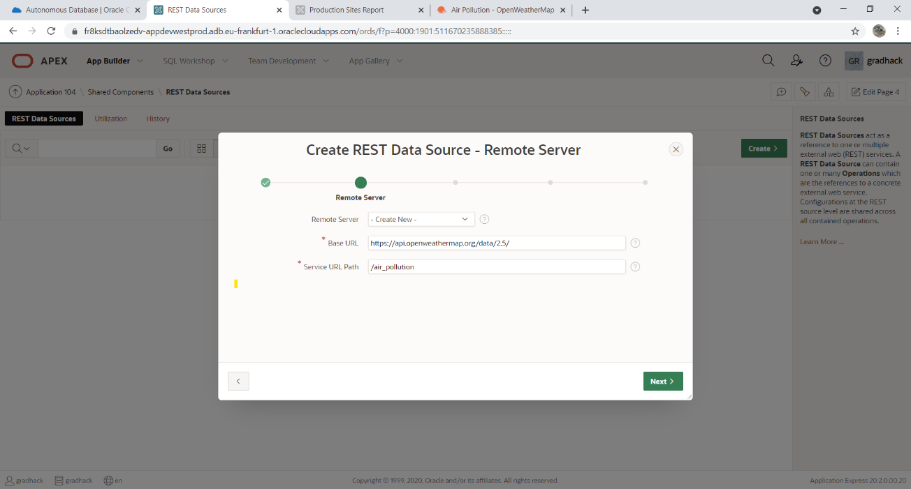
7. Authentication:  
   - Authentication required : yes  
   - Credentials: enter new credentials  
   - Autehntication type: URL Query String  
   - Name: appid  
   - Value: *** your openweathermap.org api key  
   - Click “Advanced”  
   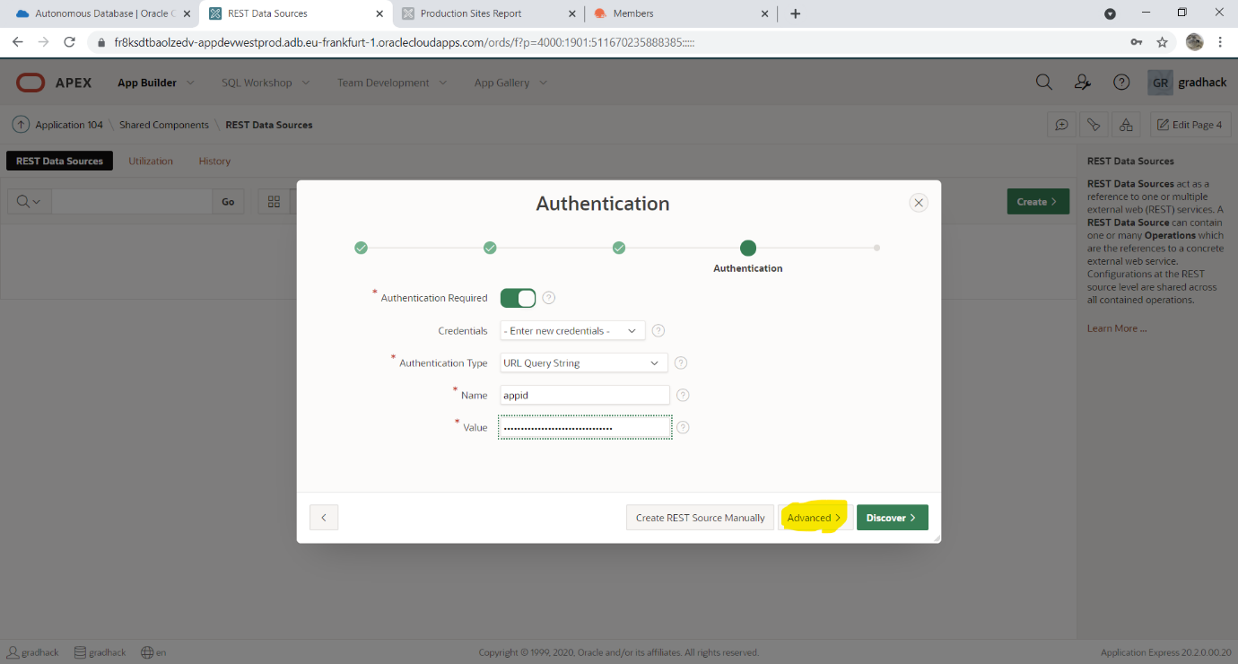
8. Parameters:  
   - Add parameter type “Query String variable”; name “lat”; value “51.5074” (latitude value for production site 1 from spreadsheet)  
   - Add parameter type “Query String variable”; name “lon”; value “-0.1278” (longitude value for production site 1 from spreadsheet)  
   - Click “Discover”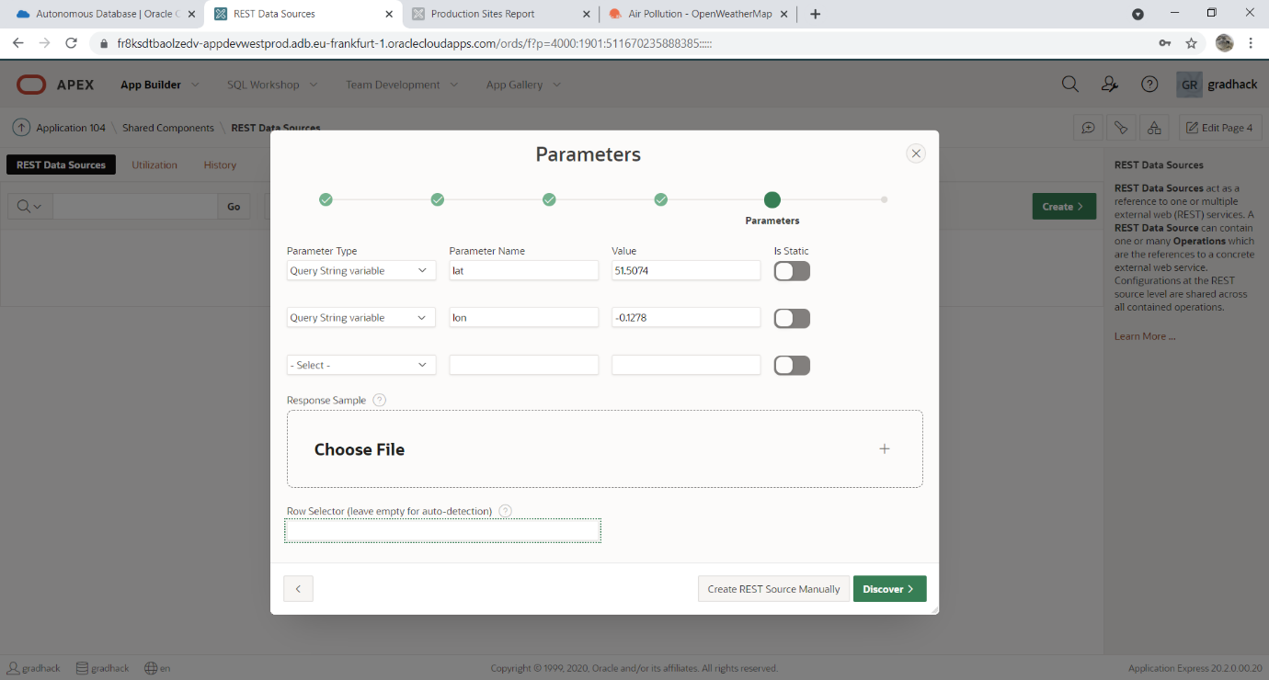
9. Preview:  
   - Click “Create REST Data Source”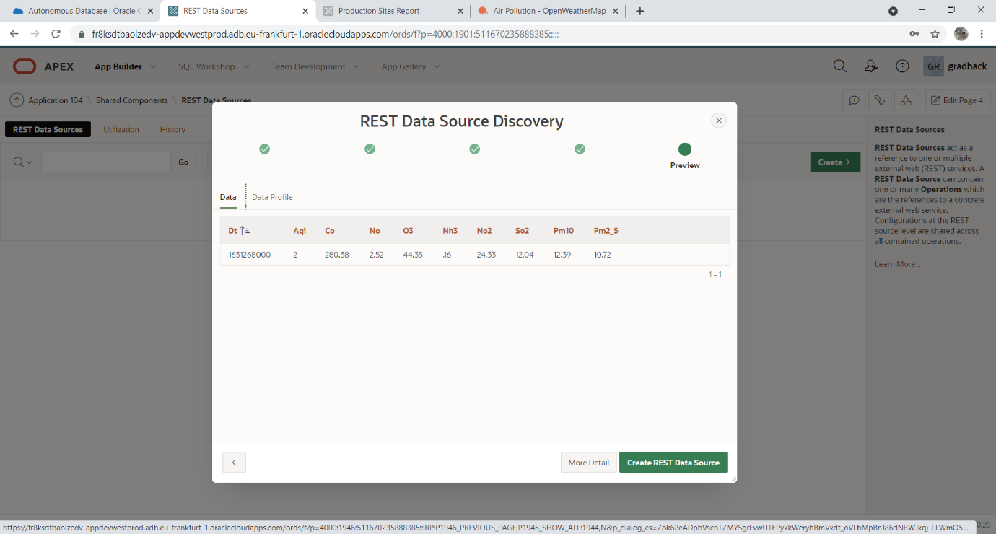
10. REST data source is now available to use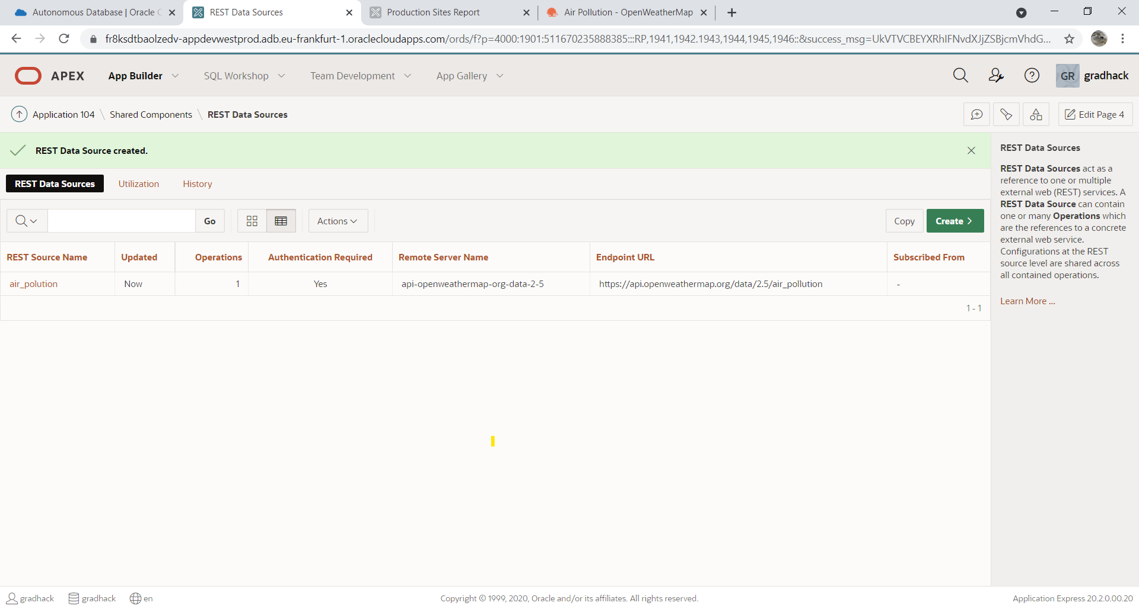

**Add live Air pollution data for each production site form**

Steps:

1. Log in to your Production Sites application
2. Navigate to Production Sites report
3. Click on the edit icon for production site 1 “Prod 1 London” 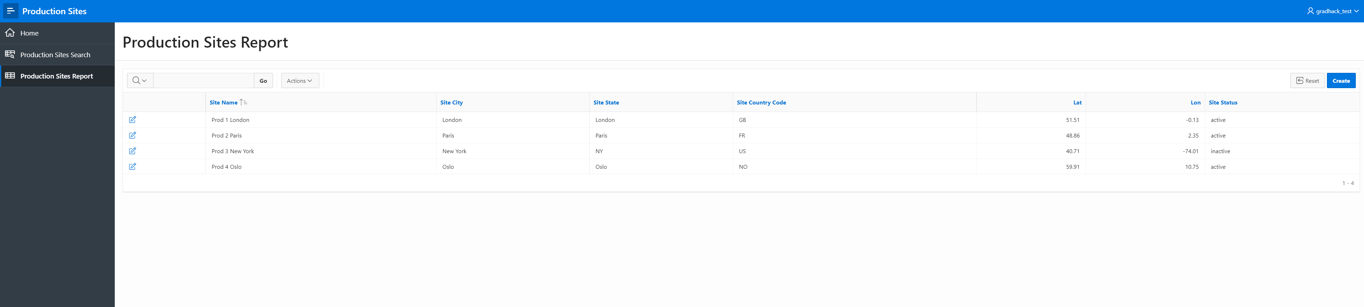
4. Click on “Edit page 4” in the bottom toolbar  
   This will open the page designer for page 4 in a new tab.  
   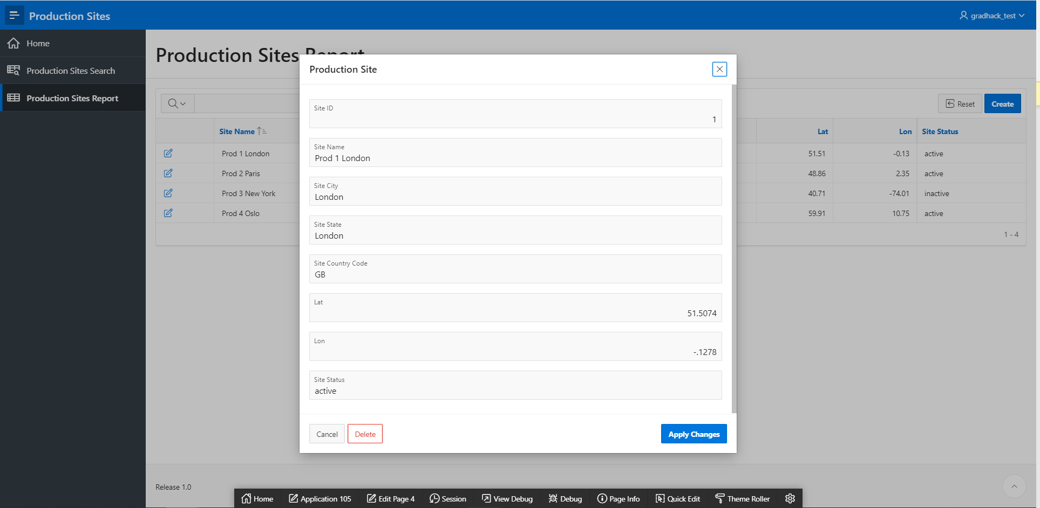
5. Right click on “Content body” in the left column of the page designer  
   Click create region  
   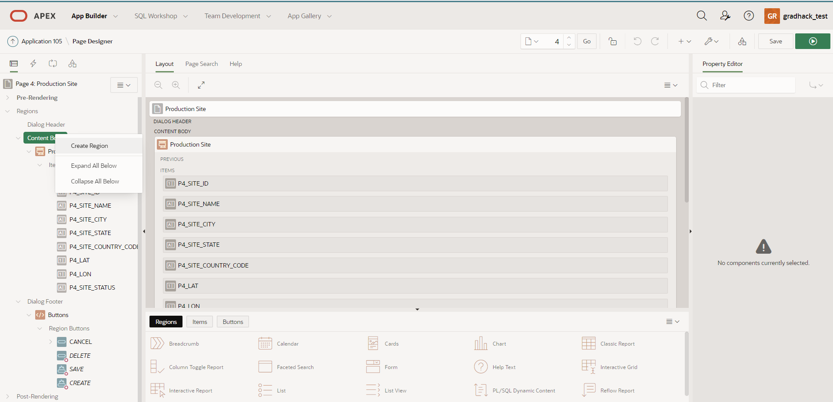
6. Your new region should be created with the name “New” and selected.  
   In the right column of the page designer edit the region parameters as follows:  
   -Identification> Title: Air polution  
   - Identification>Type: Classic report  
   -Source> Location: REST Source  
   -Source>REST source : air_polution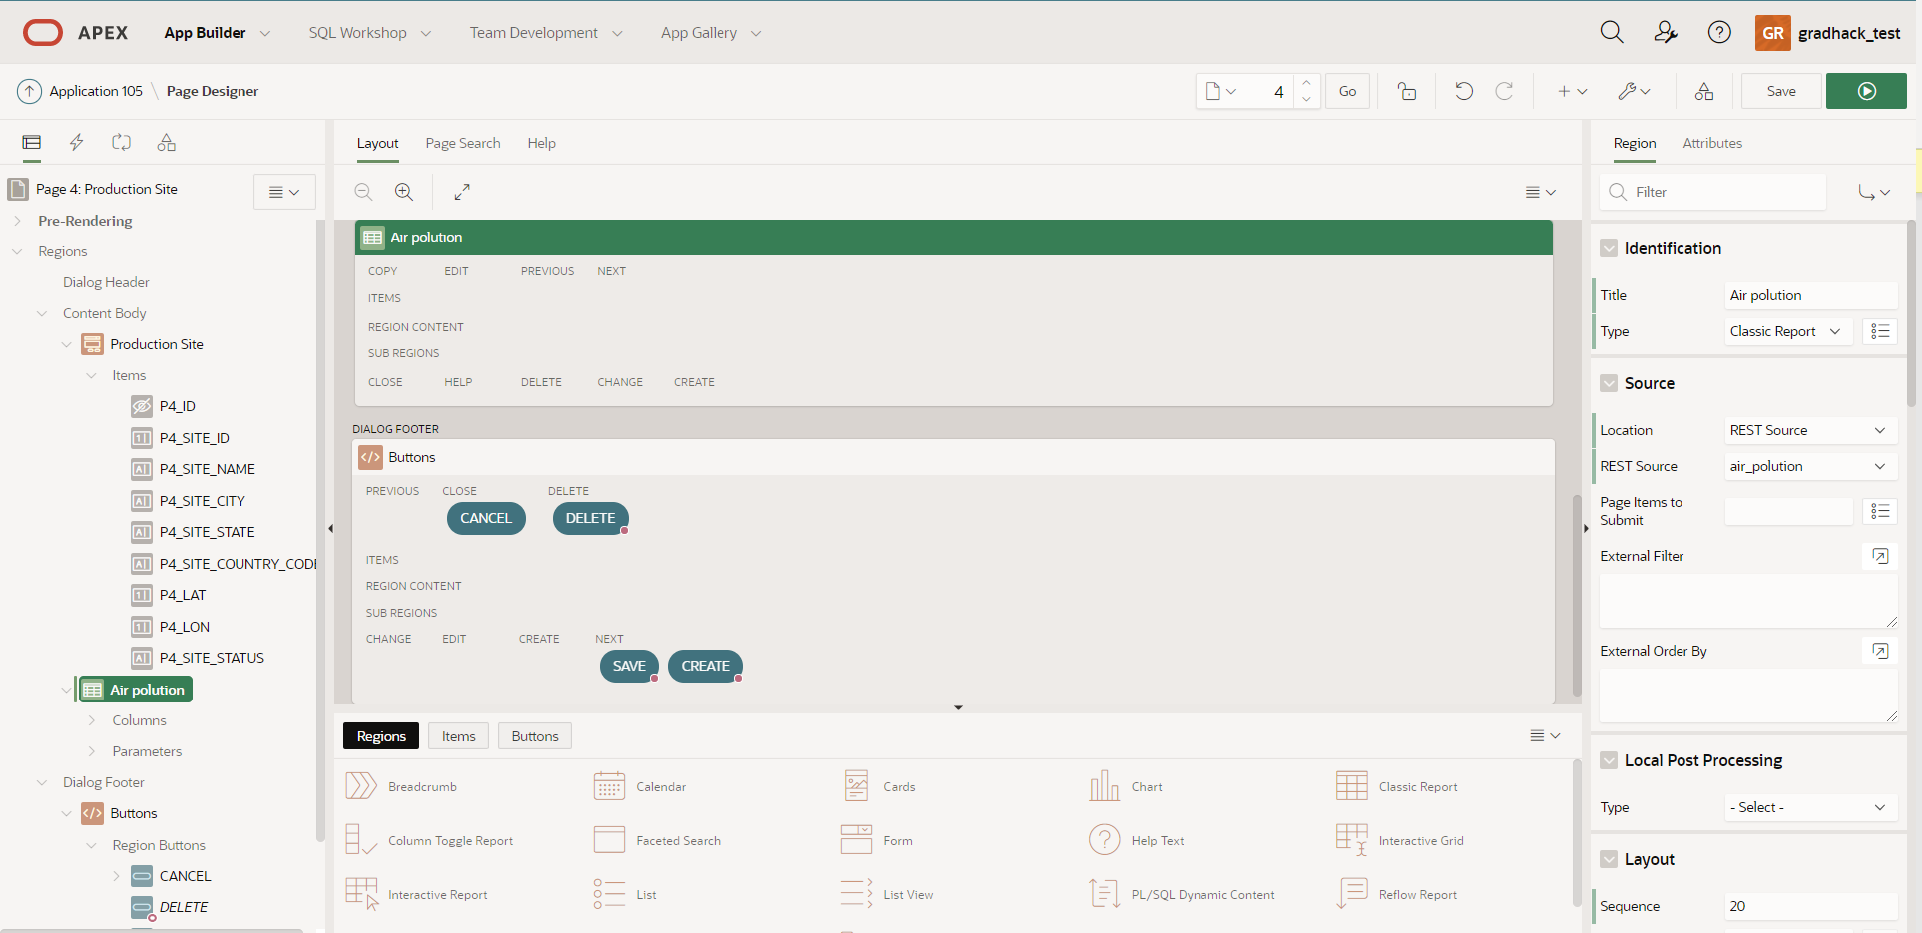
7. In the left column of the page desginer:  
   Drag your region “Air polution” above the “Production Site” region  
   Click Parameters > Lat  
   In the right column of the page designer change the “Lat” details as follows:  
   Value>Type: Item  
   Value>Item: P4_LAT  
   Click Parameters > Lon  
   In the right column of the page designer change the “Lon” details as follows:  
   Value>Type: Item  
   Value>Item: P4_LON  
   click “SAVE” button in the top right of the page designer.  
   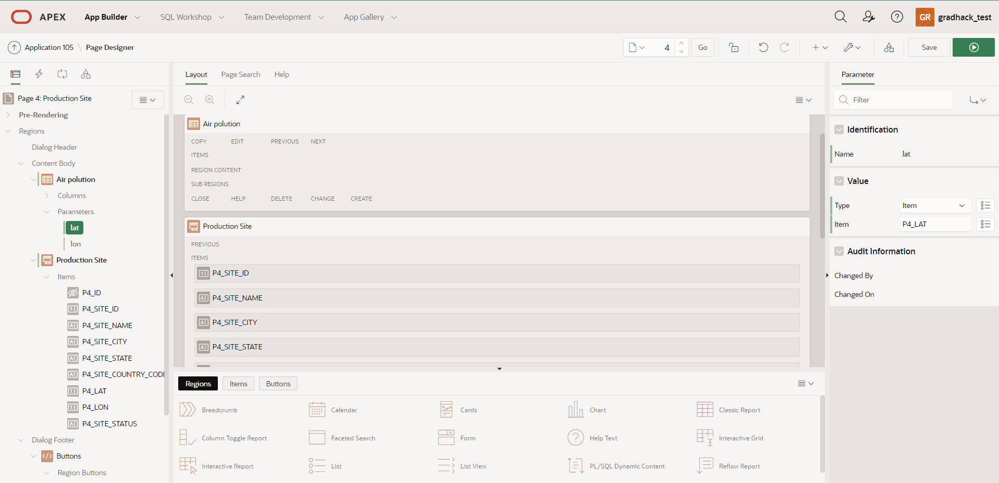
8. In your application tab:  
   Refresh the page   
   Click on the edit icon for production site 1 “Prod 1 London” 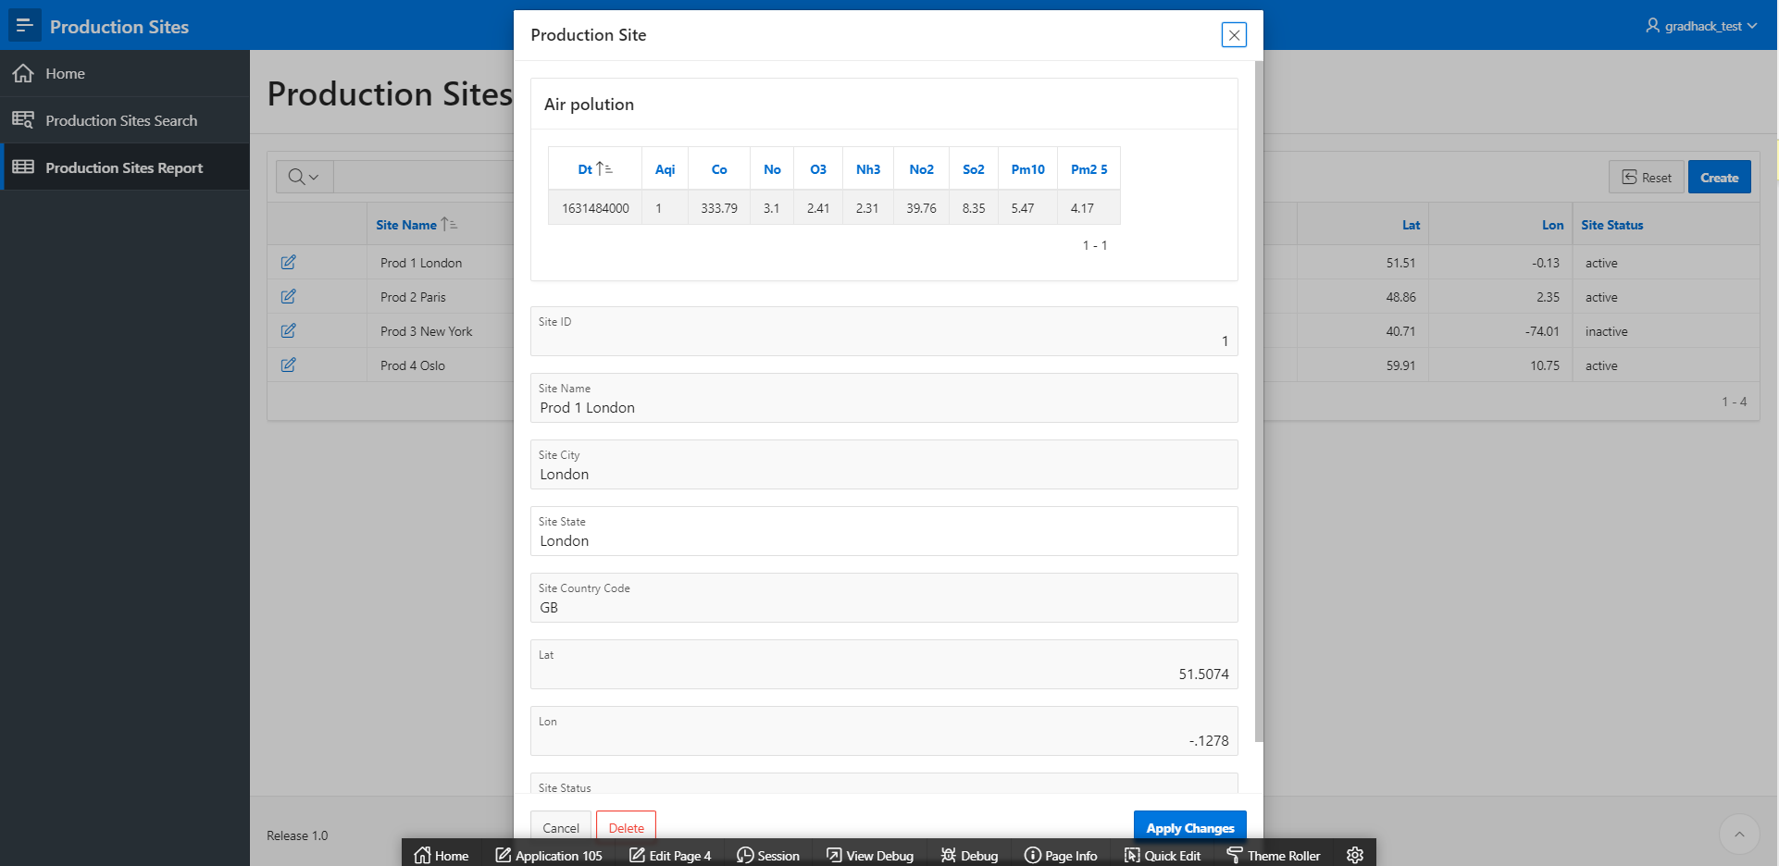

**Synchronize REST data locally**

Steps:

1. Navigate to Shared components > Rest Data Sources
2. Click on “air_polution” data source  
   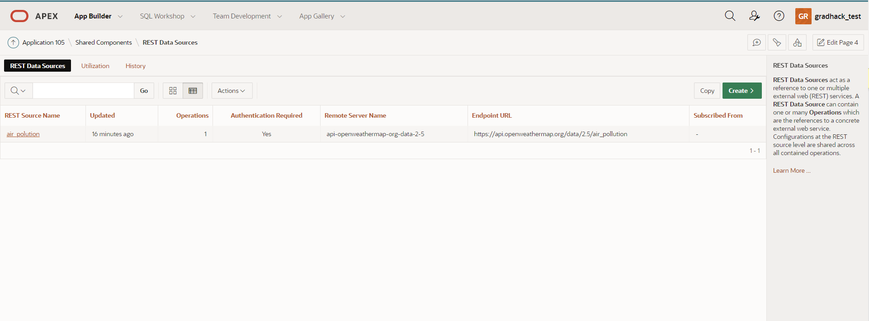
3. Click on “Edit Data Profile”  
   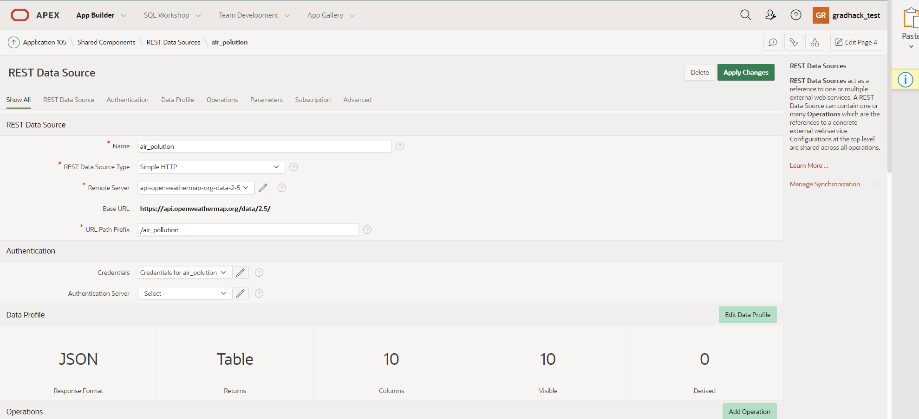
4. Click on “Add column”  
   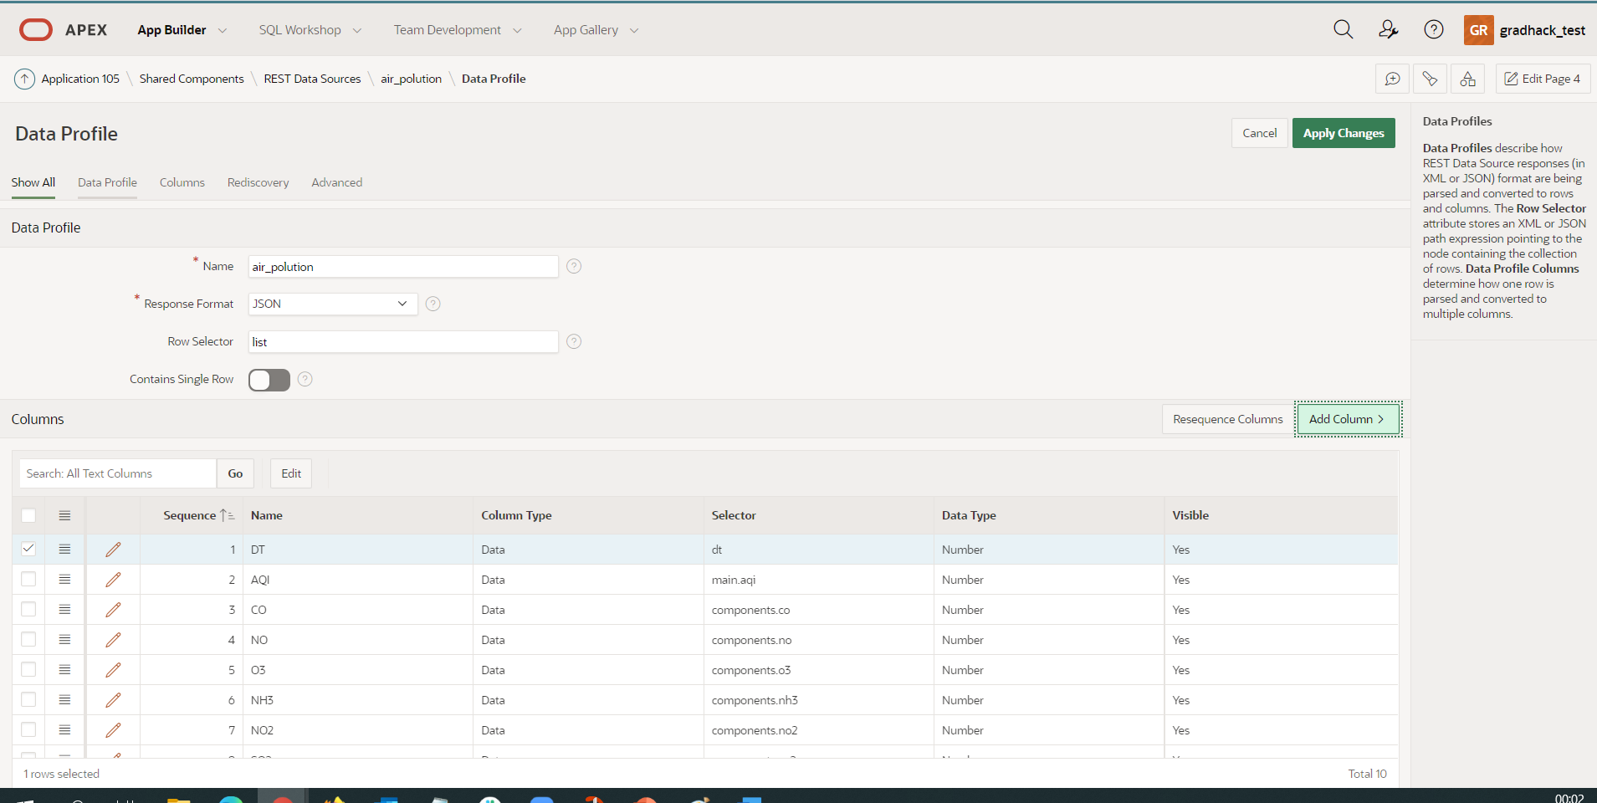
5. Add column for latitude  
   Name: lat  
   Filterable: yes  
   Visible: yes  
   Column type: Data  
   Selector : coord.lat  
   Data Type: Number  
   click “Create”  
   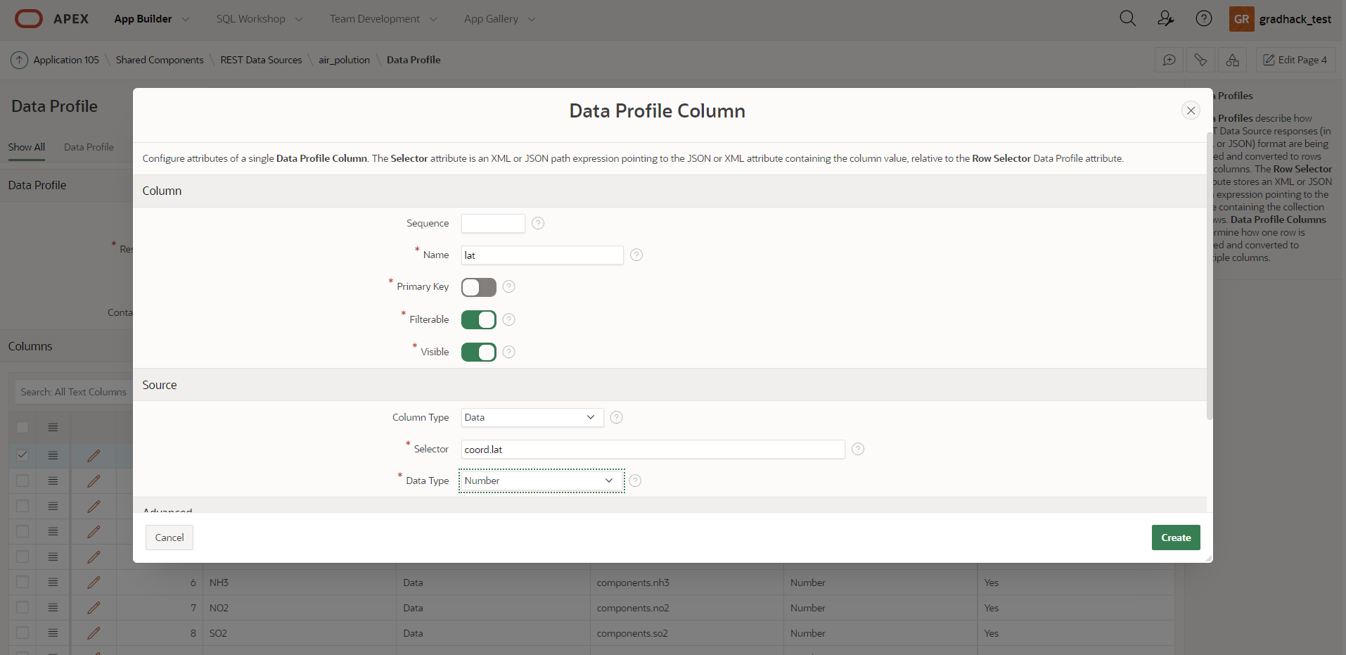
6. Add column for longitude  
   Name: lon  
   Filterable: yes  
   Visible: yes  
   Column type: Data  
   Selector : coord.lon  
   Data Type: Number  
   click “Create”  
   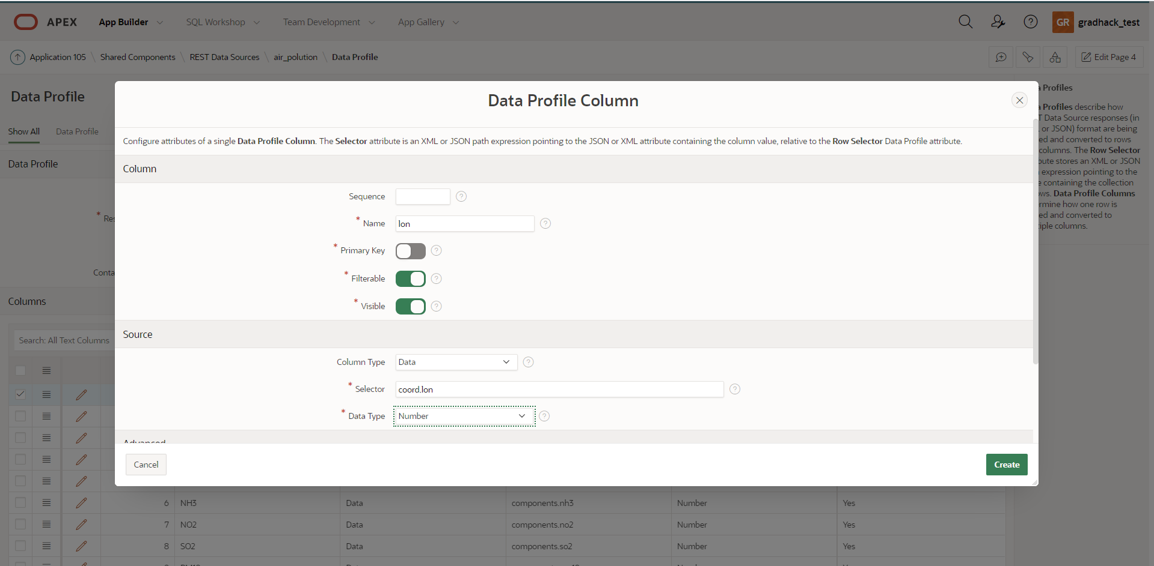
7. Add column for synchronization date  
   Name: sync_date  
   Filterable: yes  
   Visible: yes  
   Column type: Derived  
   SQL Expression : current_date  
   Data type: Date  
   click “Create”  
   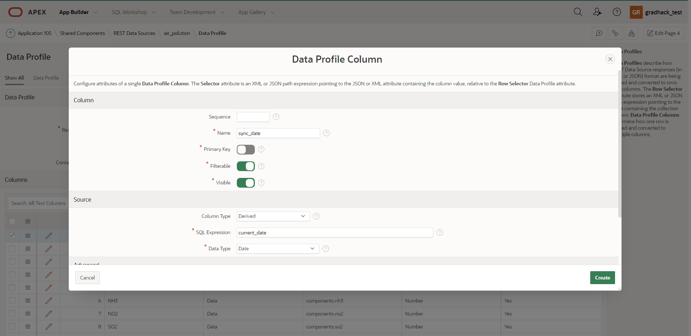
8. Remove “list” from Data profile >Row Selector  
   Click Edit in the columns region  
   Edit the selector for the columns by adding “list.” In front of the existing columns.  
   Click “Apply changes” in the top right of the page.  
   Your data profile should look like this  
   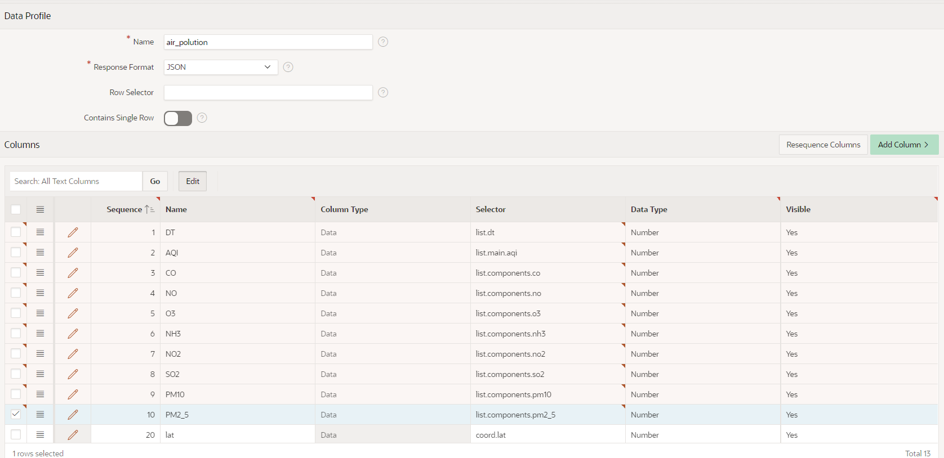
9. Navigate back to the rest source “air_polution” using the breadcrumb bar or by clicking “Cancel”
10. Click on “Manage synchronization” in the right side of the page  
    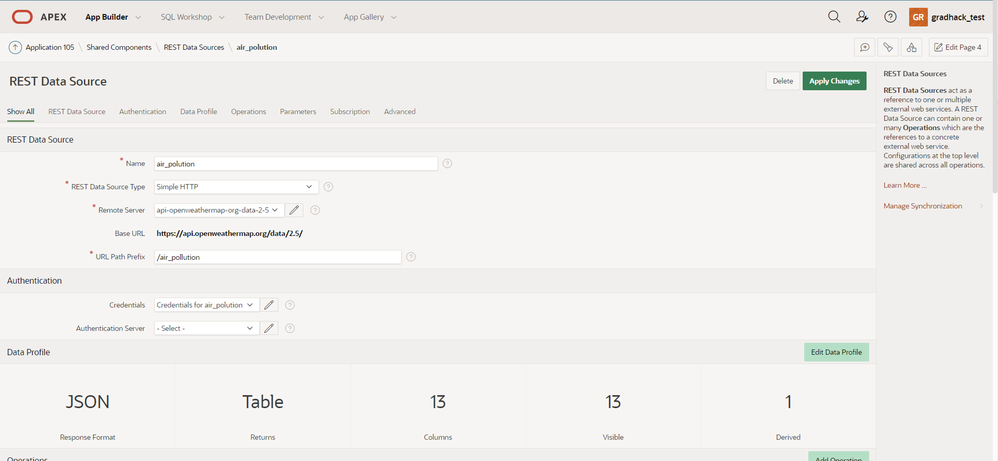
11. Enter table name : AIR_POLUTION_CURRENT  
    Click Save  
    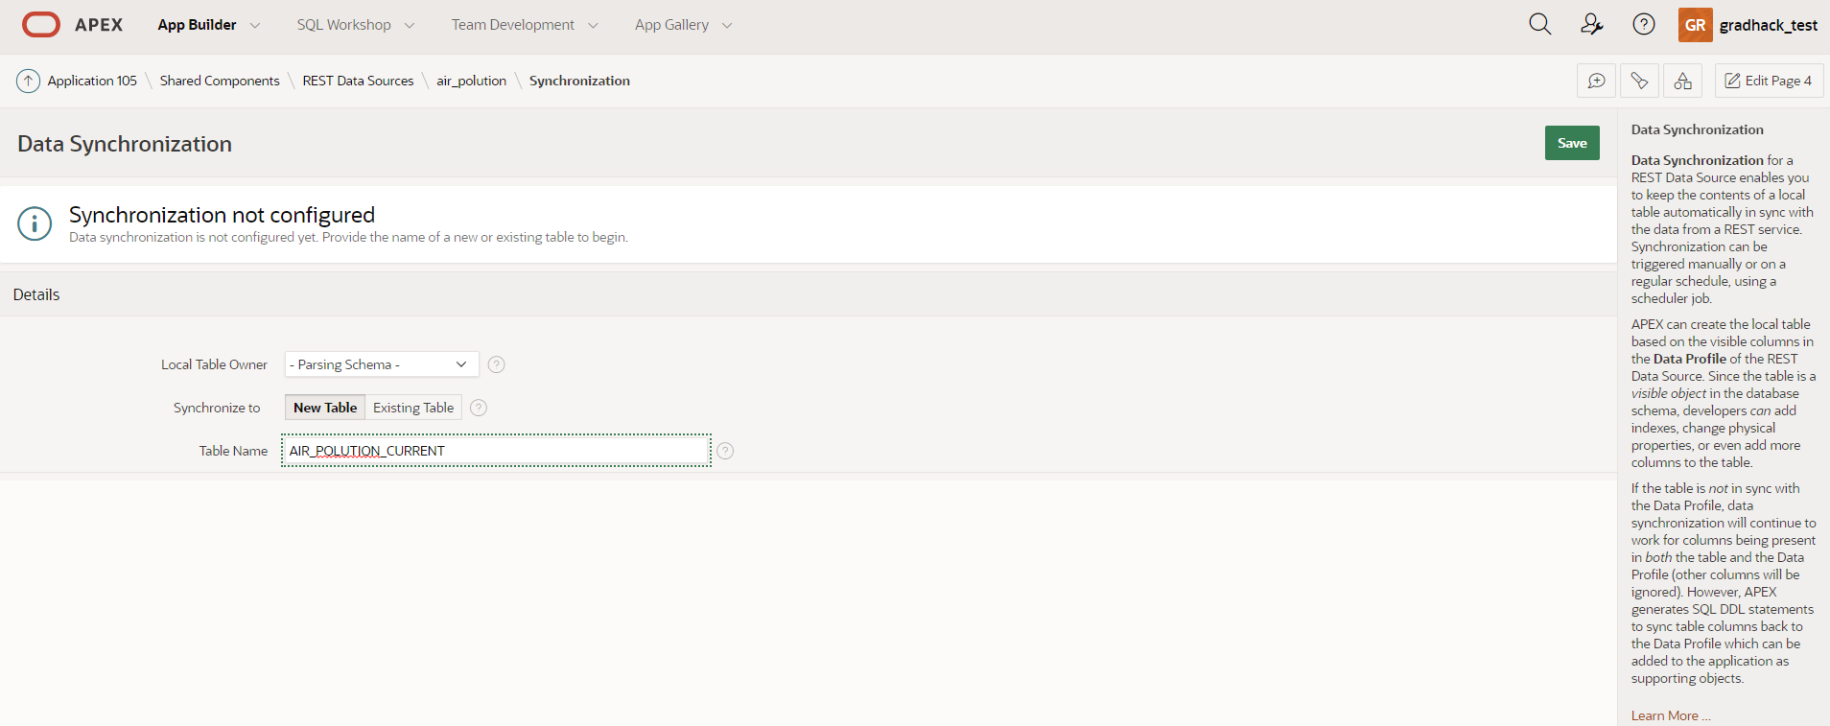
12. Click “Create Table”  
    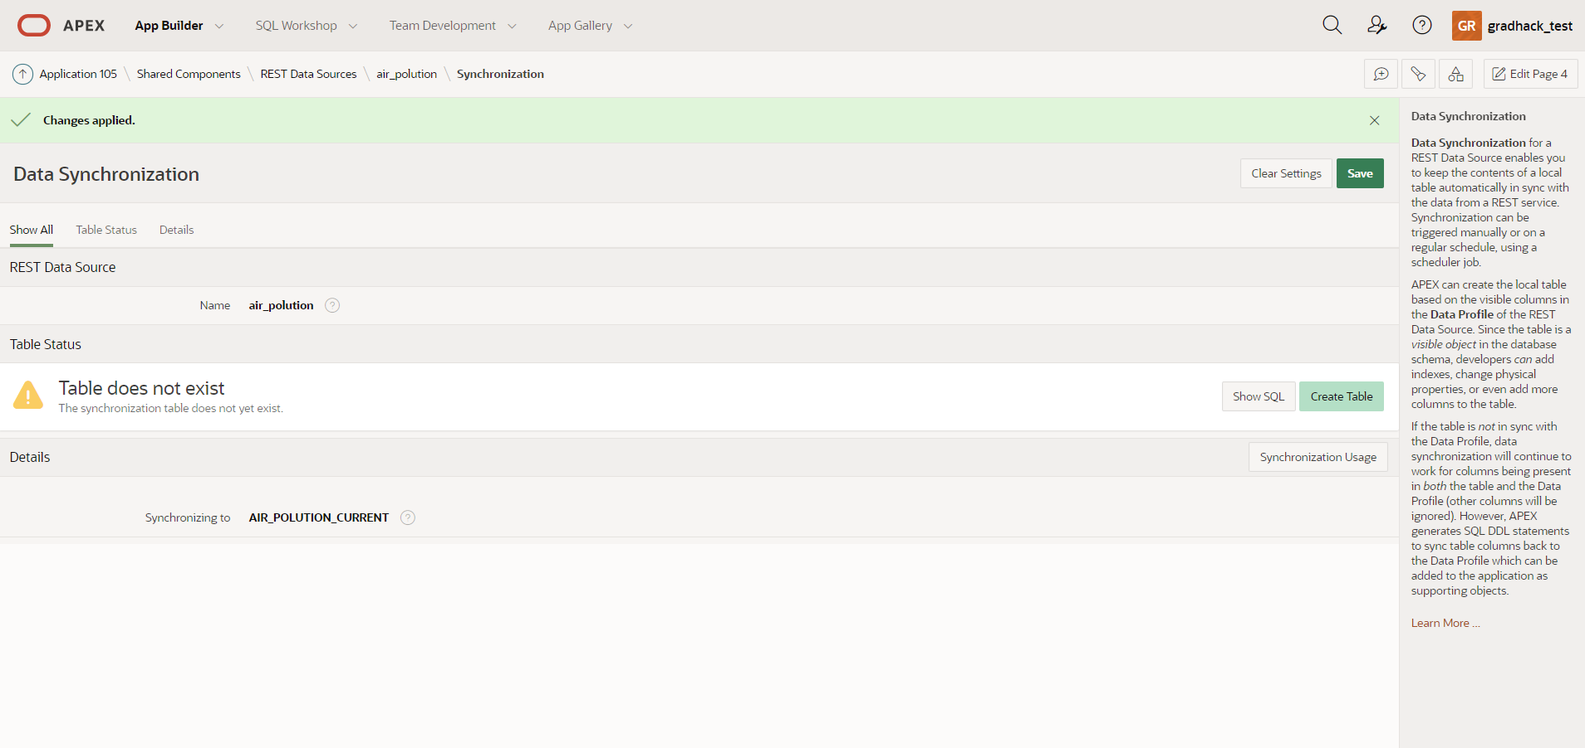
13. Change Synchronization Type : Replace  
    click on Synchronization Schedule wrench icon  
    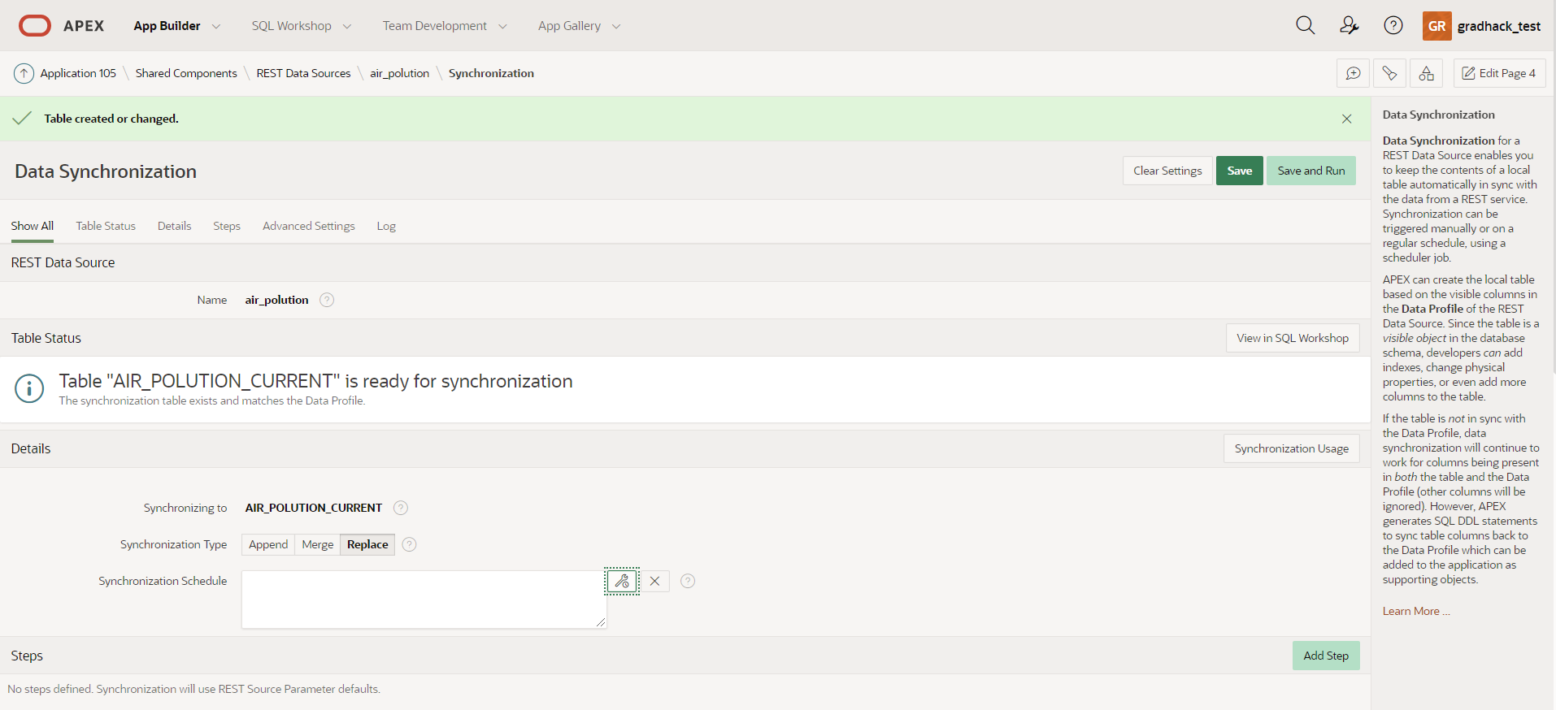
14. Set Frequency : Minutely  
    Interval: 10  
    click “Set Execution Interval”  
    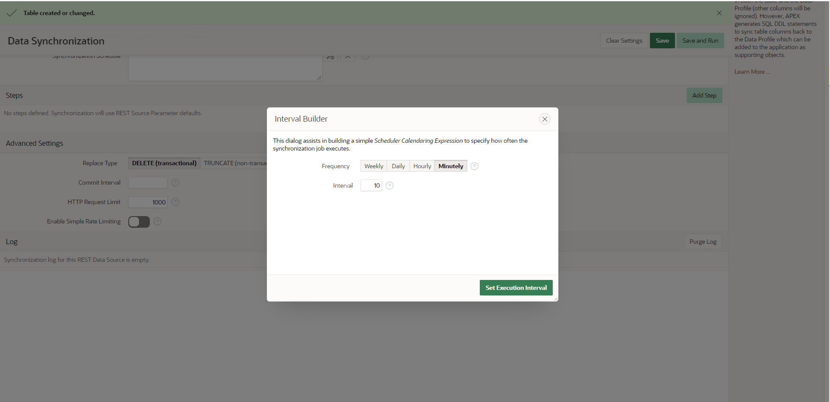
15. Click Add step  
    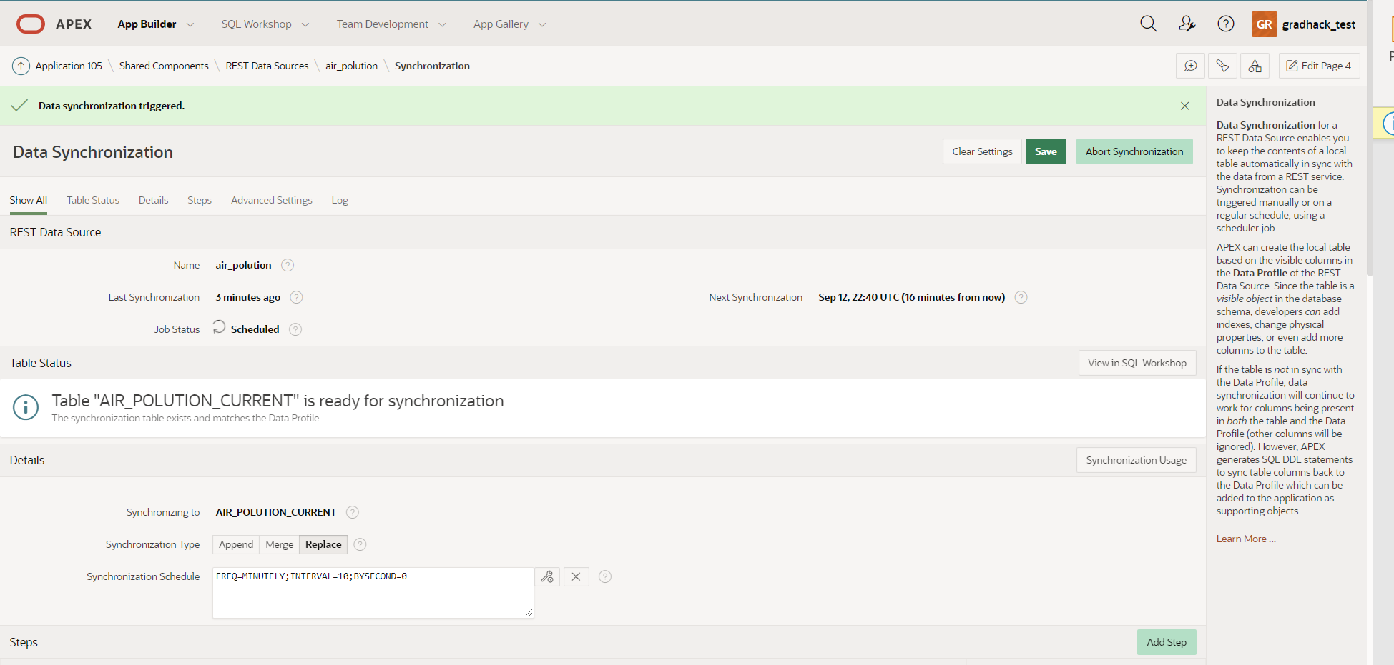
16. Fill in parameter values “lat” and “lon” for each location  
    Click “Apply changes”  
    Repeat for each location  
    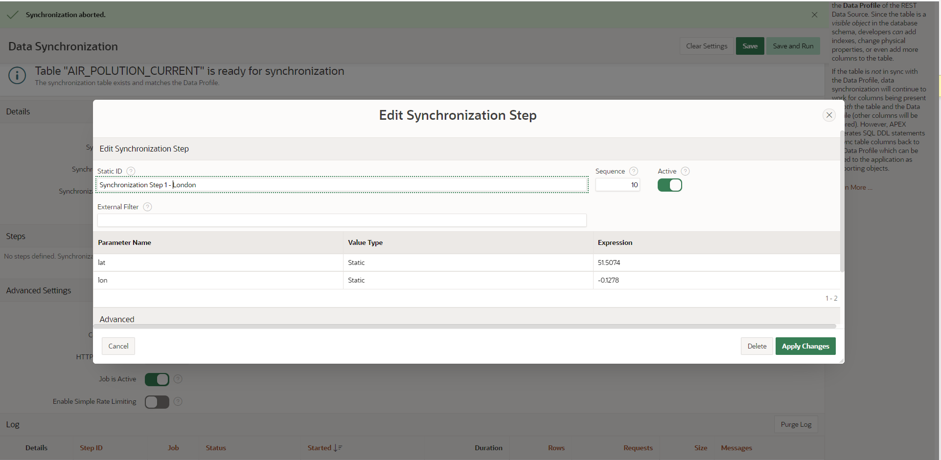
17. Click “Save and Run”  
    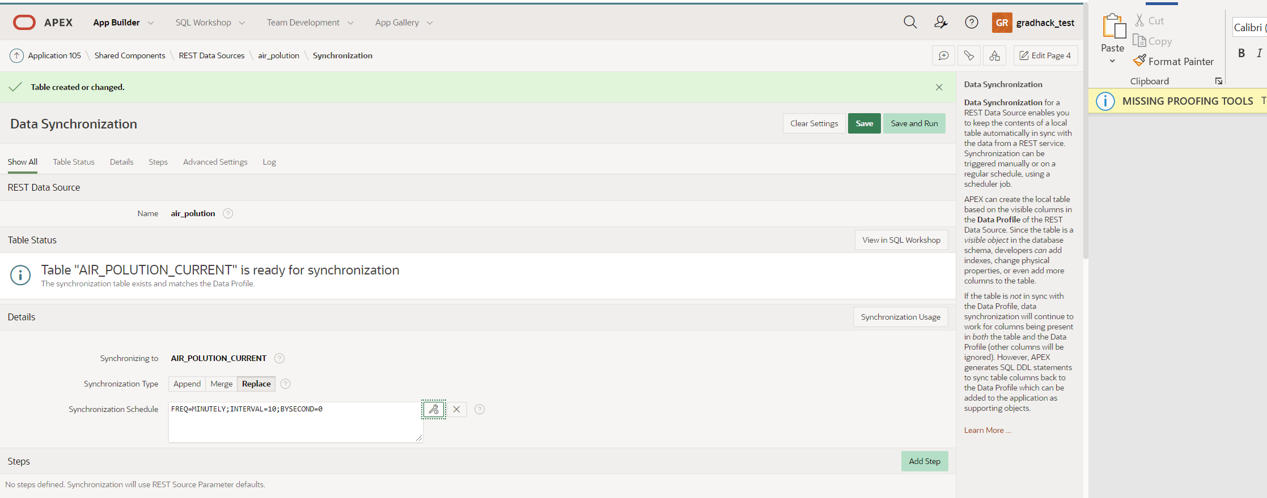

**Include Air pollution data in production sites search page**

Steps:

1. In your application tab, navigate to “Production Sites search”  
   click “Edit page 2” in the bottom toolbar  
   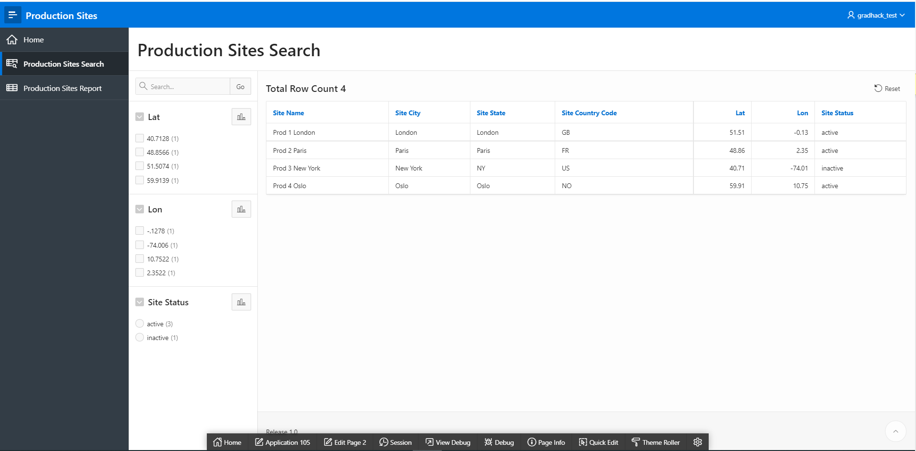
2. Select your “Production sites” region in the left column of the page designer  
   In the right column Change Source>Type: SQL query  
   click the code editor button on the right of SQL query  
   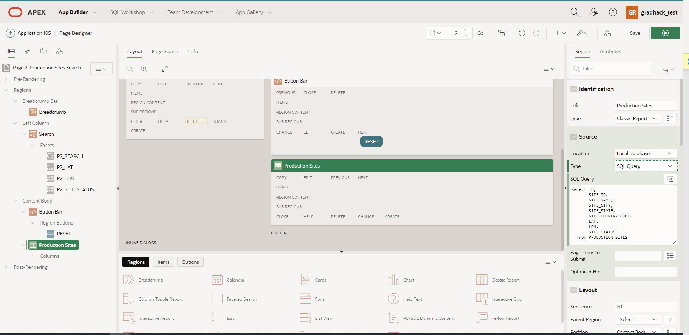
3. Click the “Query Builder” hammer button  
   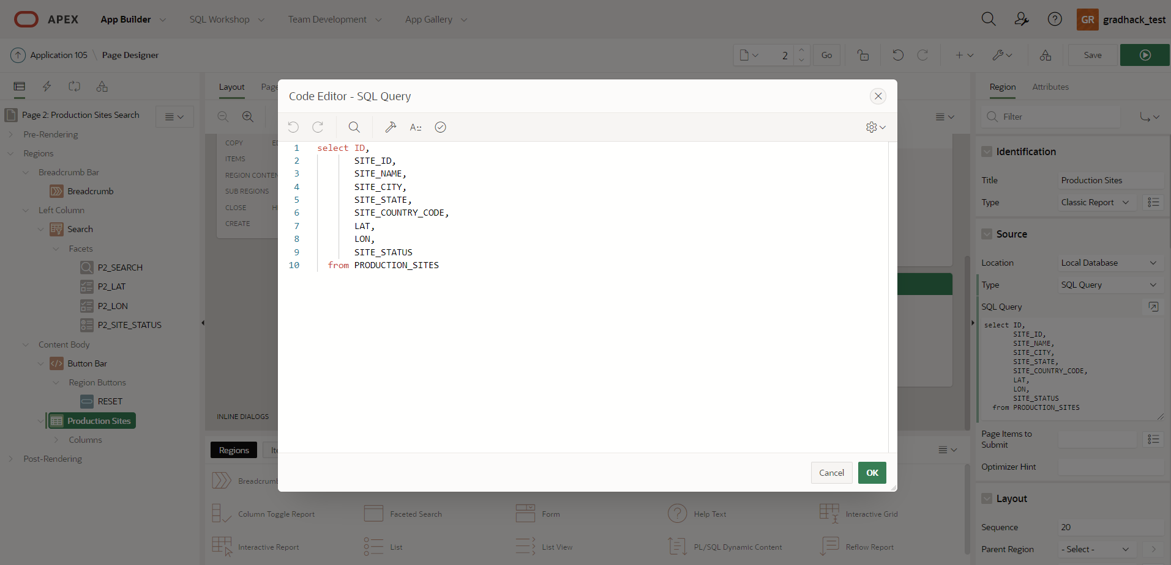
4. In the pop-up warning click “Create”  
   In the left column click the tables: PRODUCTION_SITES and AIR_POLUTION_CURRENT  
   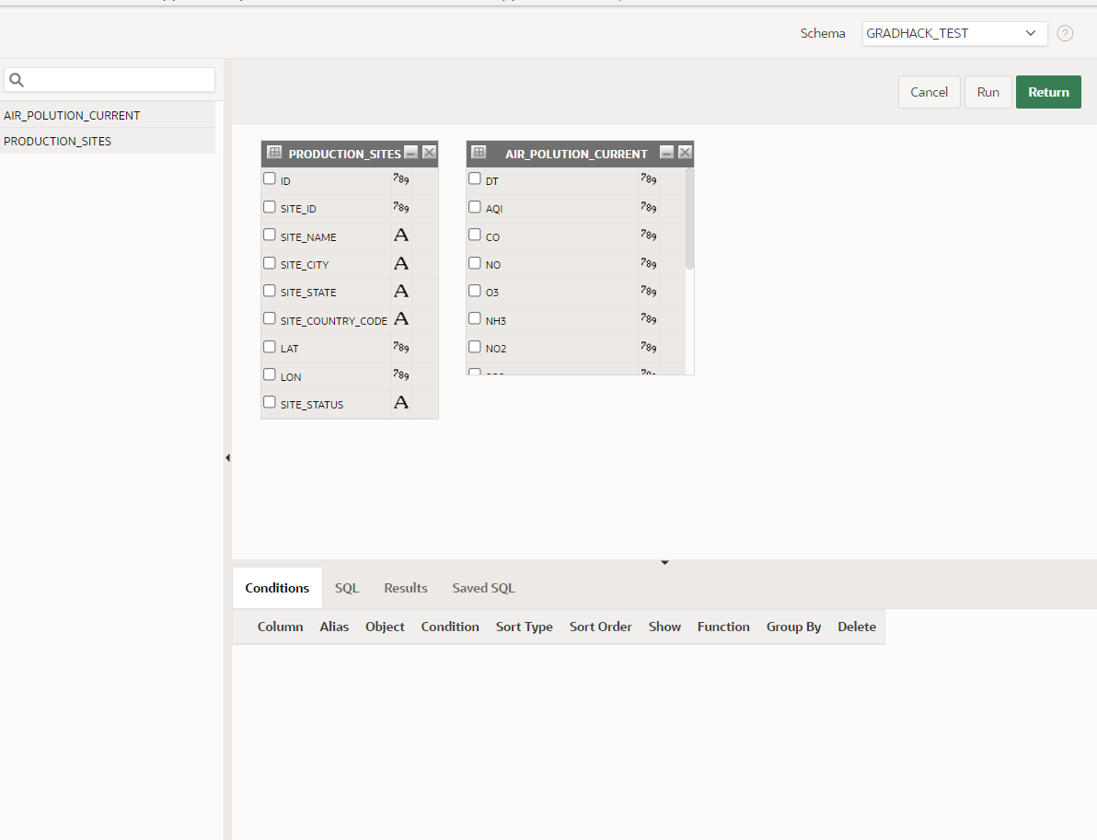
5. Click PRODUCTION_SITES “LAT” grey square and Air_polution_current “lat” grey square so they become dark grey.  
   Click PRODUCTION_SITES “LON” grey square and Air_polution_current “lon” grey square so they become dark grey.  
   Check all columns in PRODUCTION_SITES  
   Check AQI and CO columns in AIR_POLUTION_CURRENT  
   Click “Return”  
   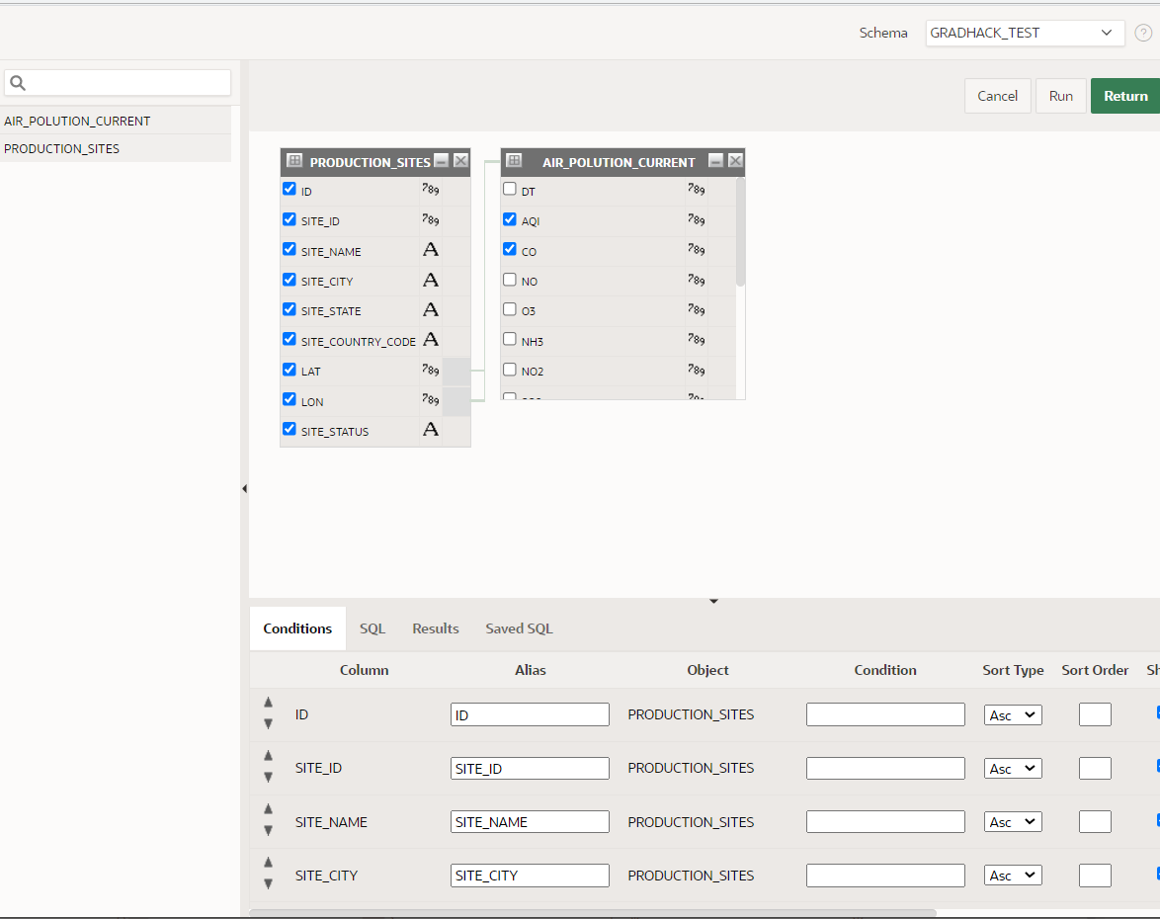
6. Click “OK”  
   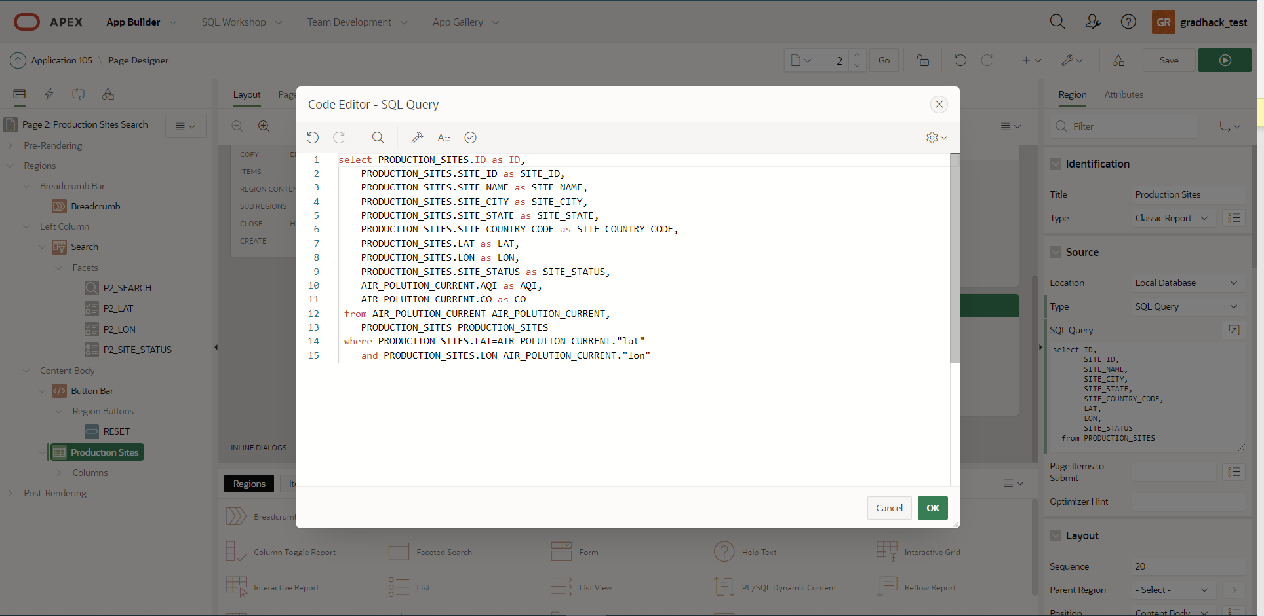
7. Click “SAVE” and “Run” play button  
   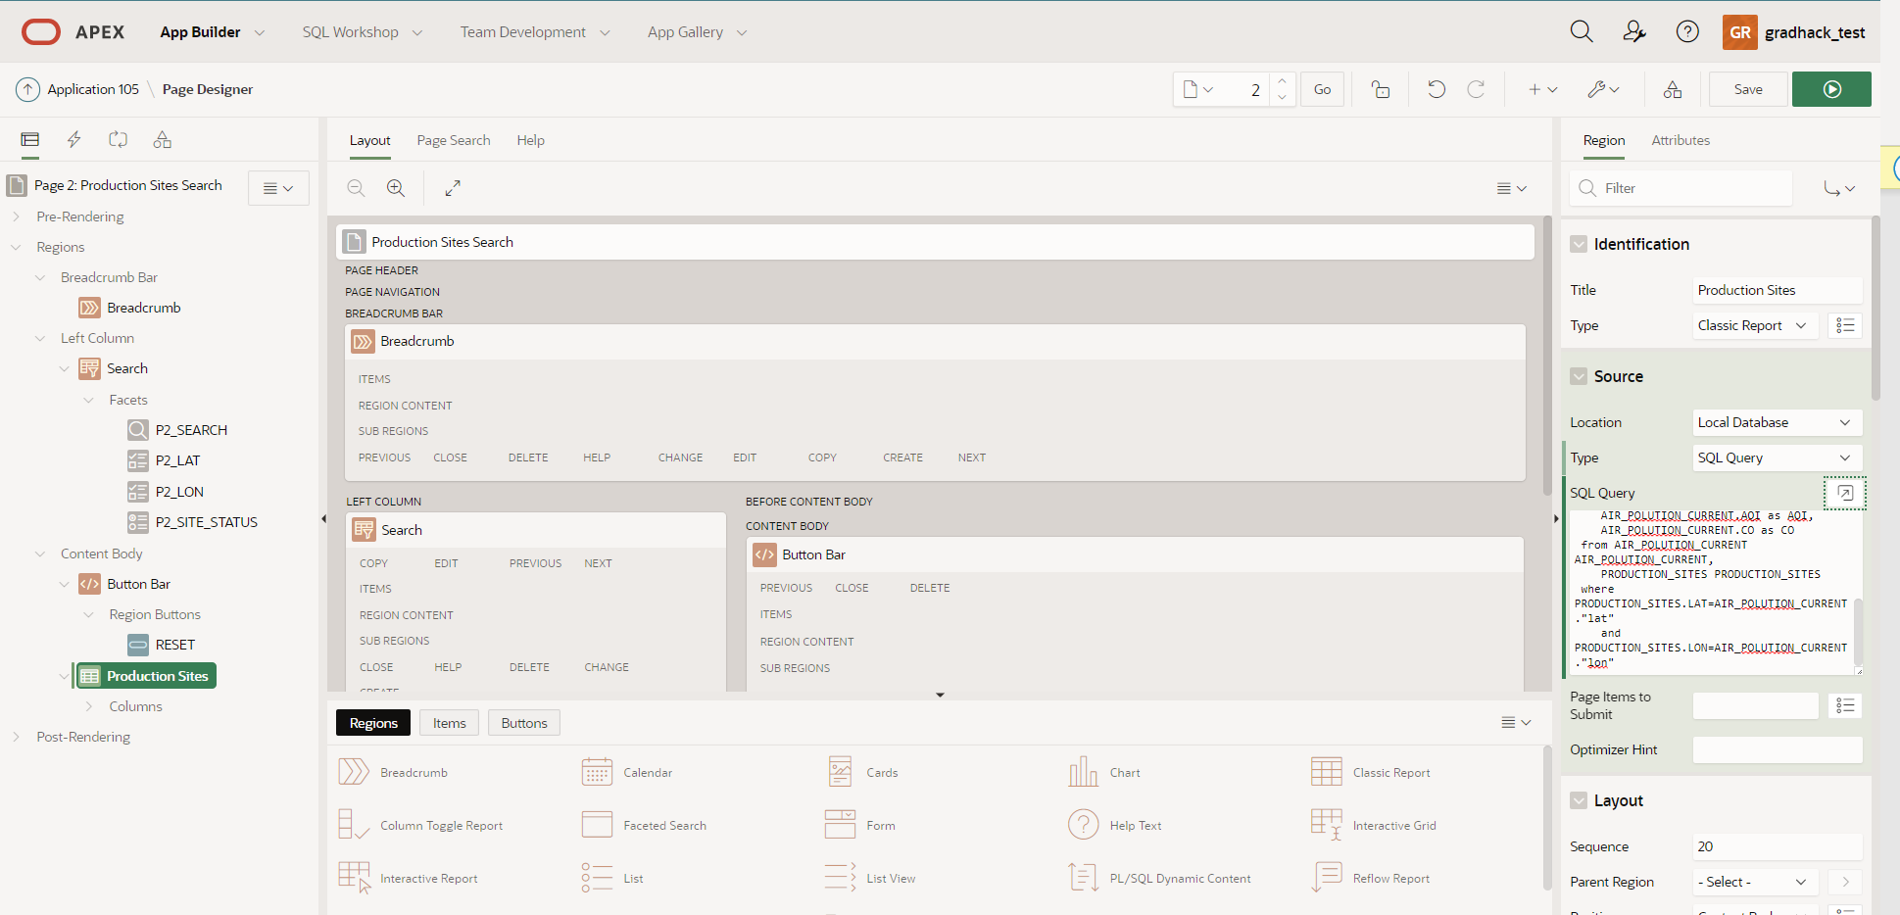
8. Your page now displays Air Quality Index and CO values for each production site.  
   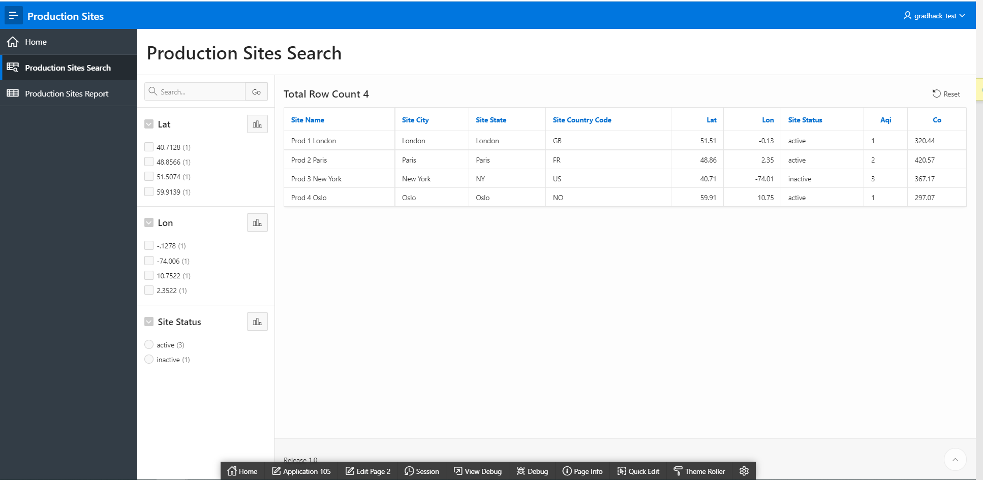

**Add graph with Air pollution evolution**

Steps:

1. Navigate to Shared Components > Rest Data Sources  
   click “Copy”  
   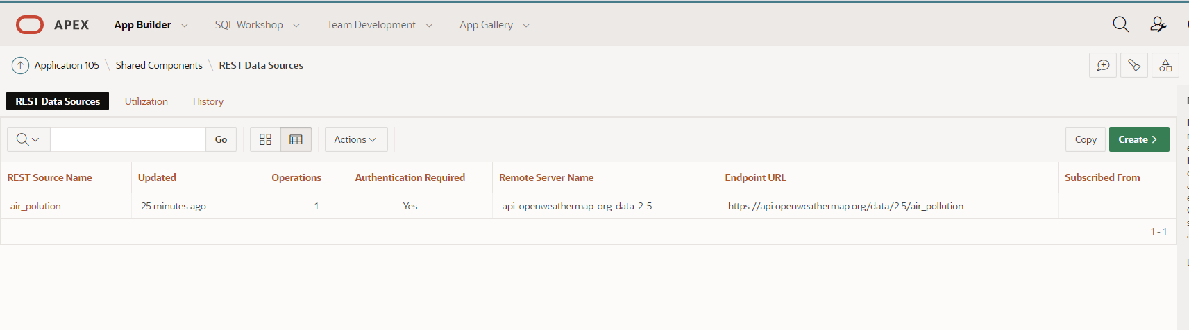
2. Create a new rest data source as a copy of air_polution.  
   New REST data source name : Air_polution_evolution  
   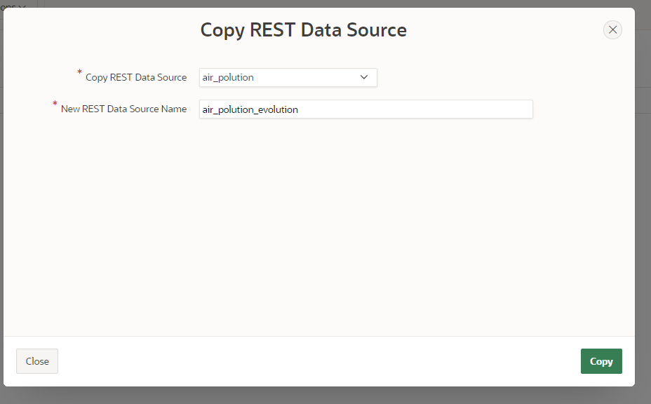
3. Click “Manage synchronization”  
   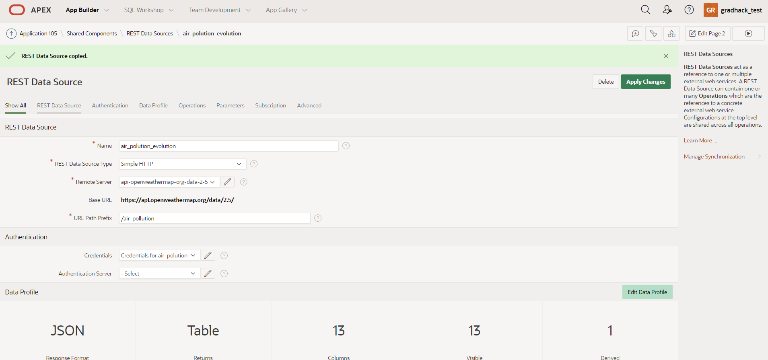
4. Add Table name : AIR_POLUTION_EVO  
   Click “Save”  
   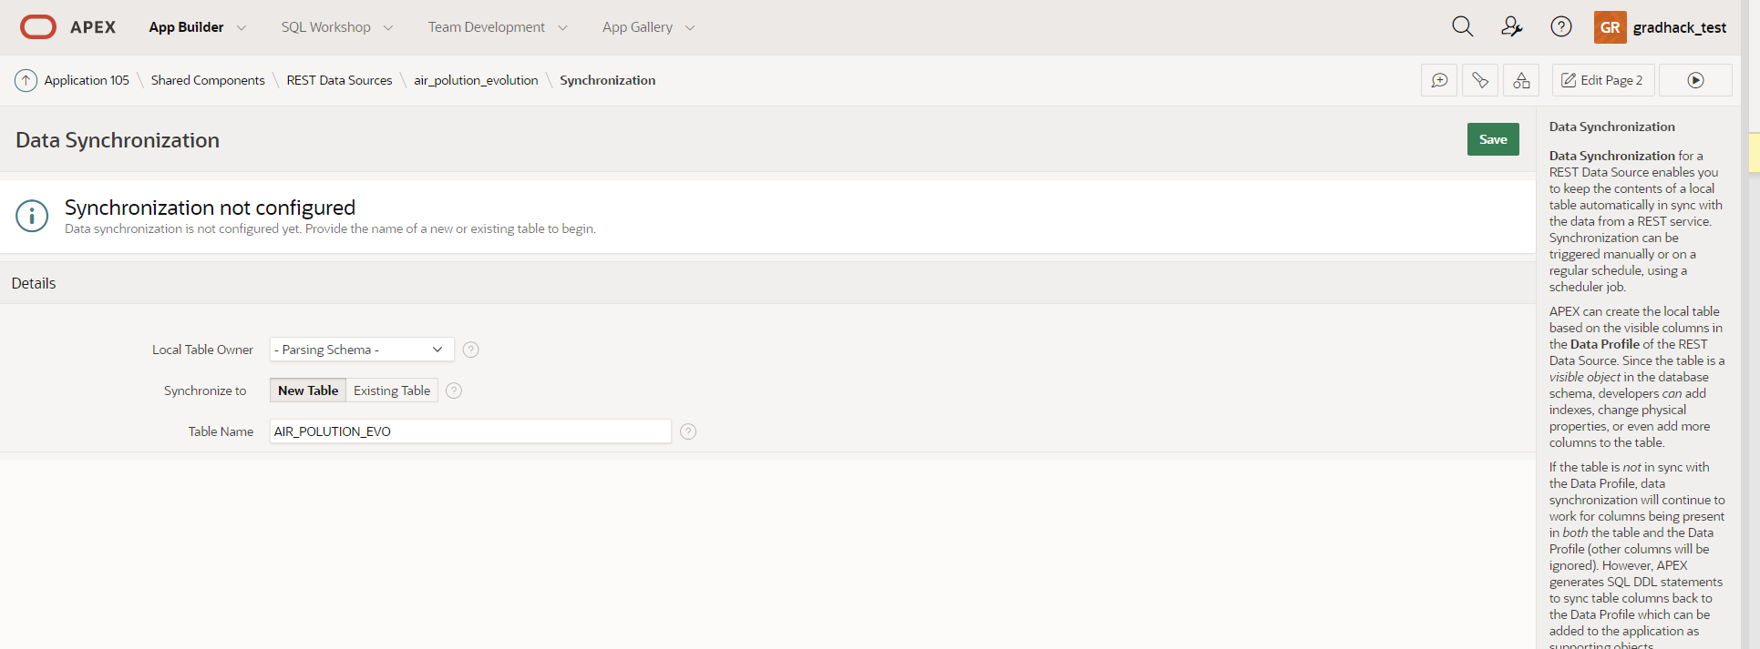
5. Click “Create Table”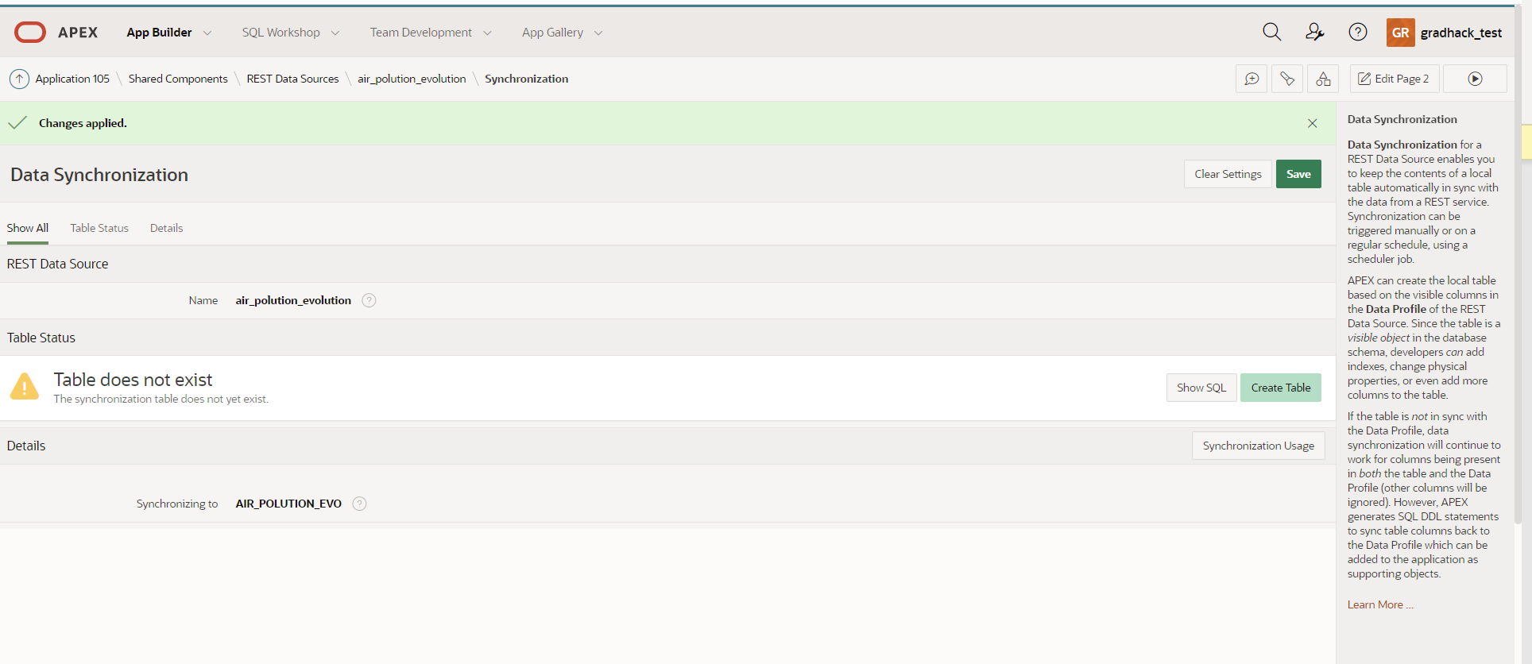
6. Define Synchronization details  
   Synchronization Type: Append  
   Synchronization Schedule: FREQ=MINUTELY;INTERVAL=10;BYSECOND=0   
   (every 10 minutes)  
   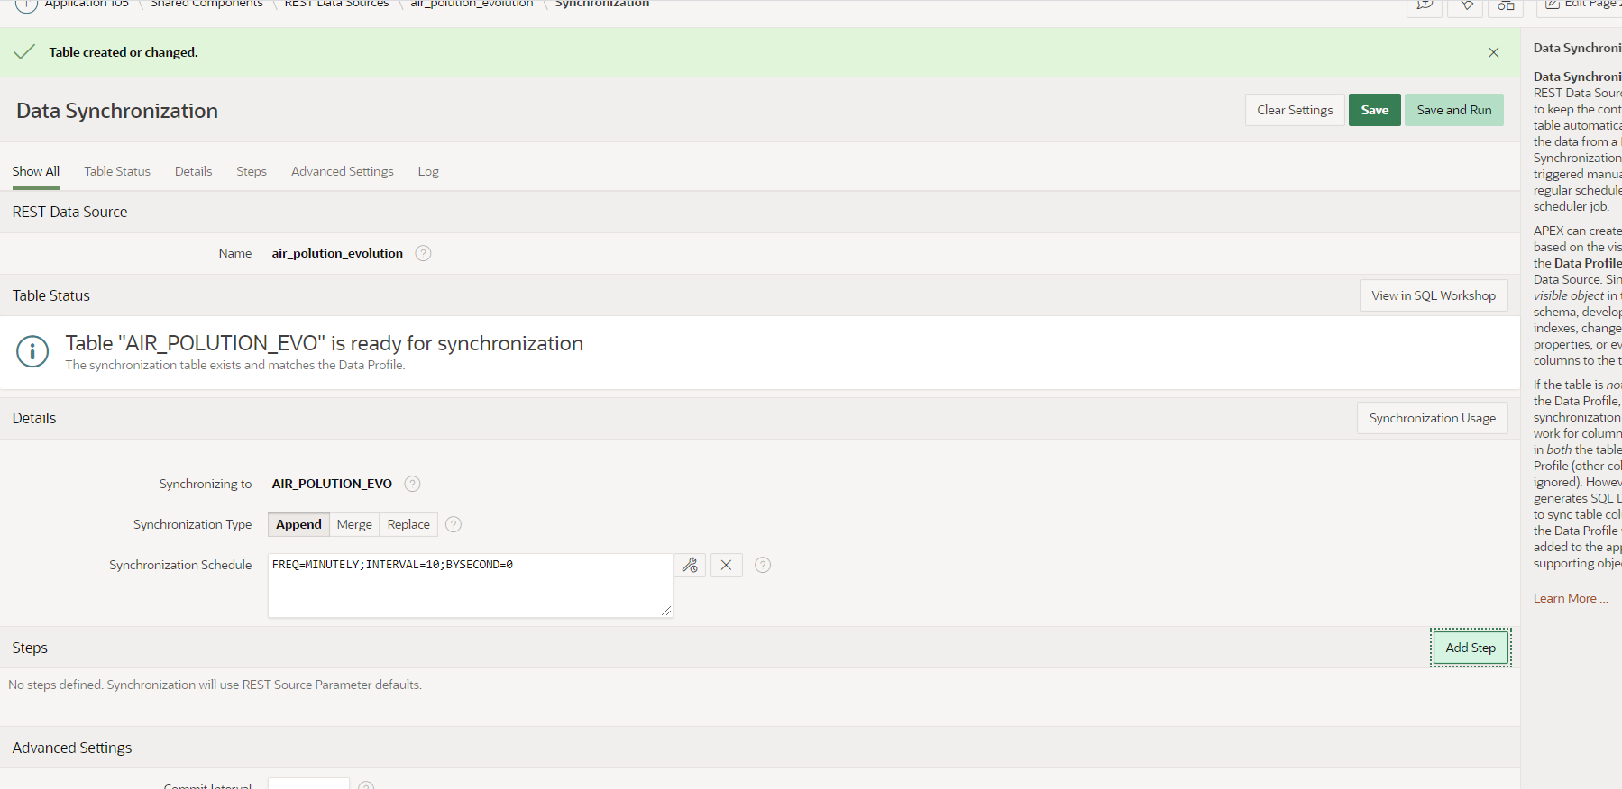
7. Add steps for each production site as before  
   Click “Save and Run”  
   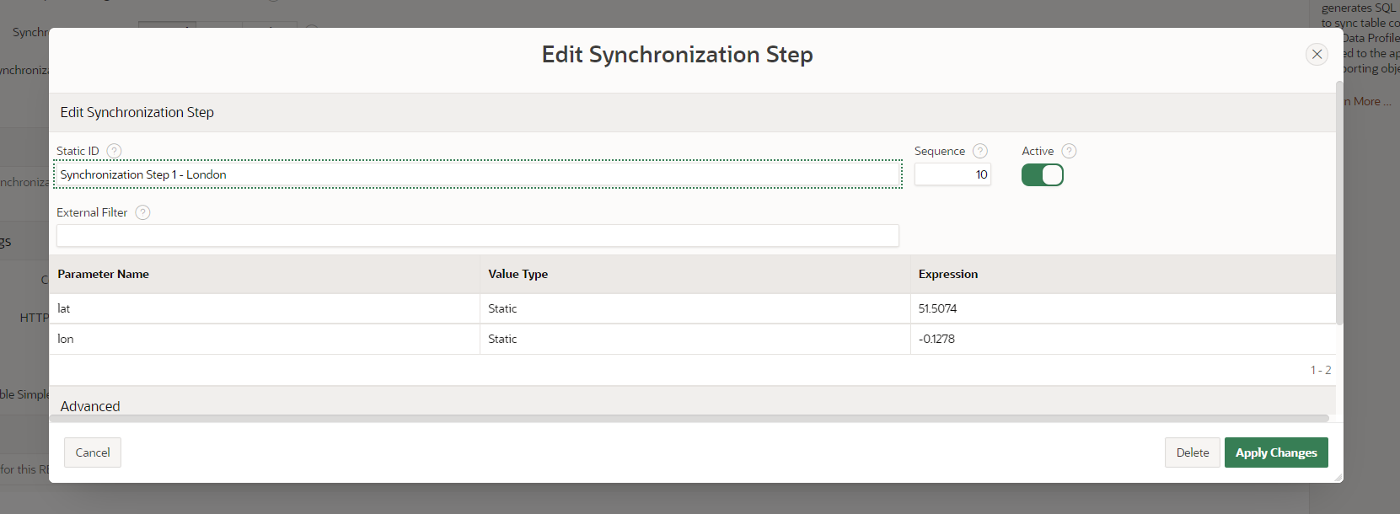
8. Navigate to App Builder  
   click “Create page”  
   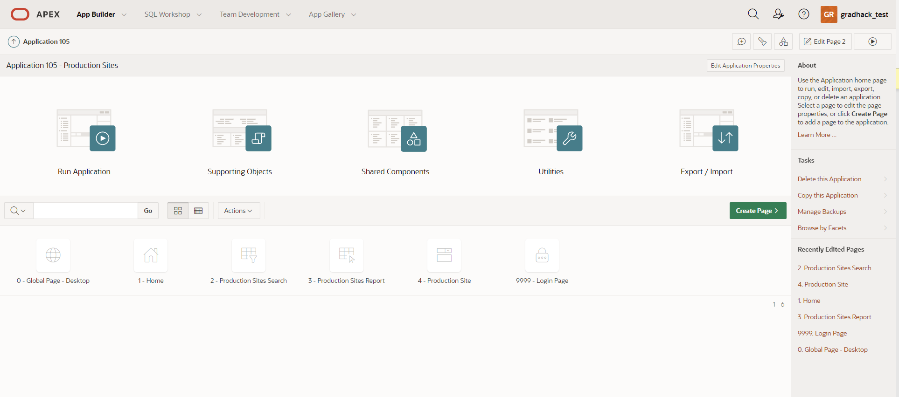
9. Click on “Chart”  
   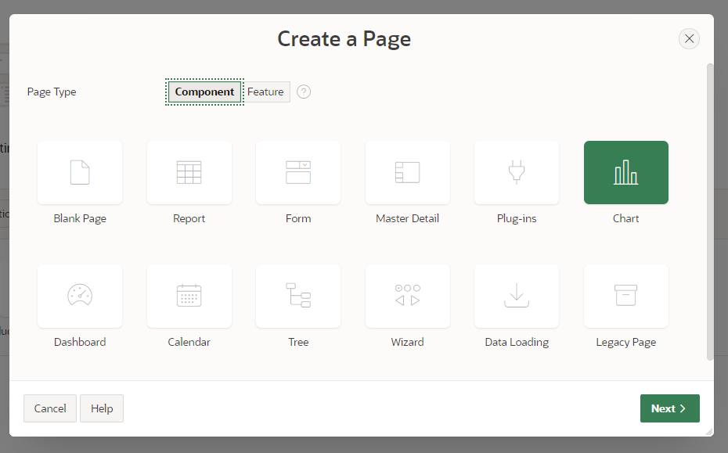
10. Click on “Bar”  
    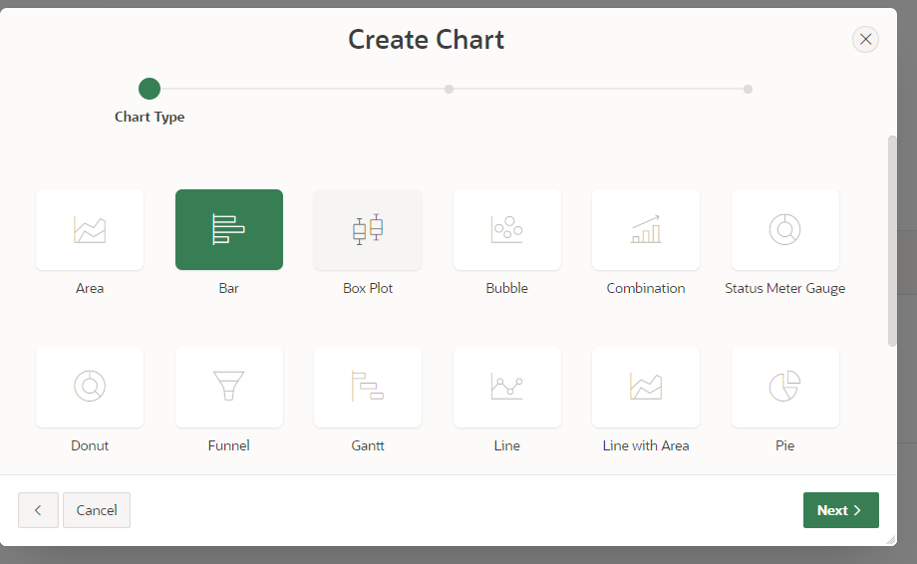
11. Enter page name: Air Pollution evolution  
    click “Next”  
    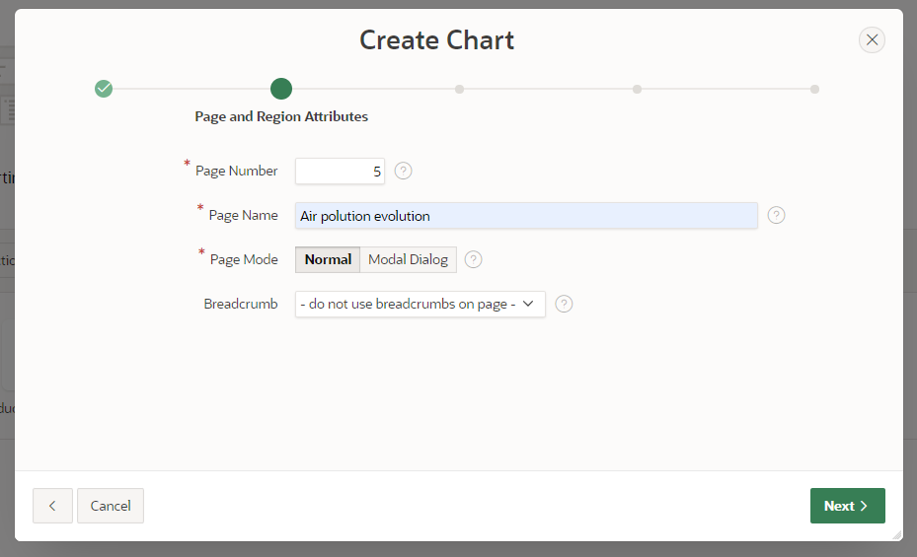
12. Choose navigation preference: Create a new navigation menu entry  
    click “Next”  
    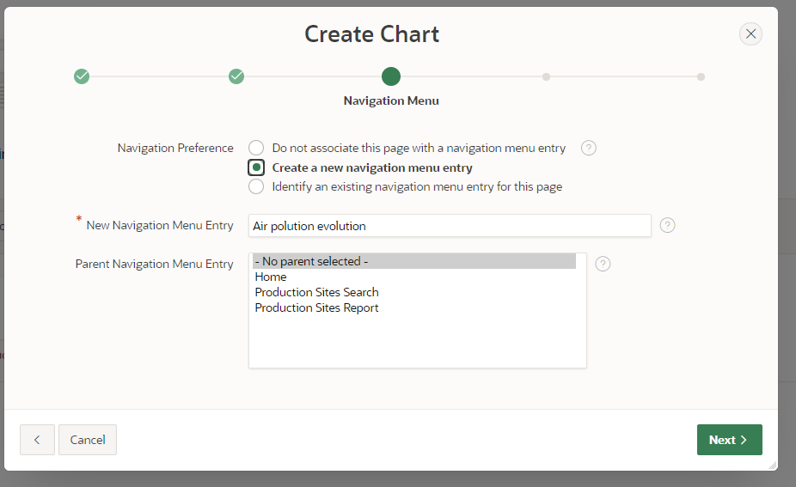
13. Change source type: SQL query  
    click the “Query Builder” button  
    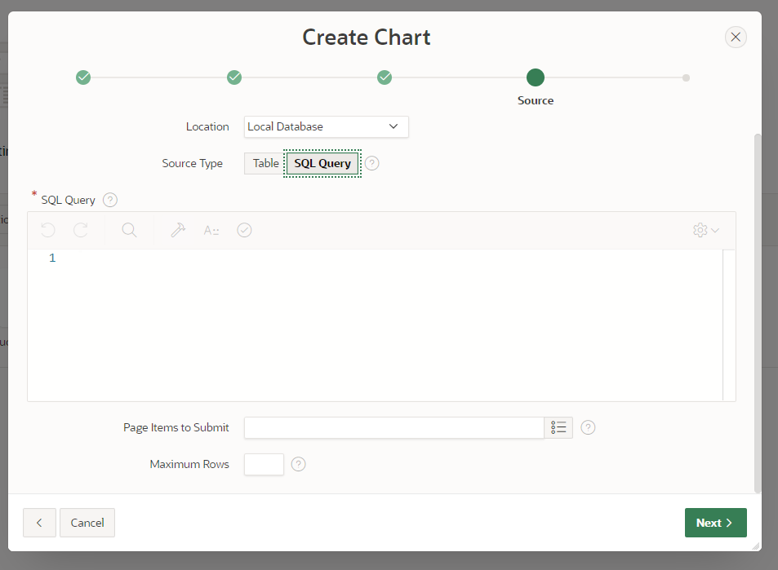
14. Click on tables PRODUCTION_SITES and AIR_POLUTION_EVO  
    Connect PRODUCTION_SITES.LAT to AIR_POLUTION_EVO.lat by clicking on the grey squares  
    Connect PRODUCTION_SITES.LON to AIR_POLUTION_EVO.lon by clicking on the grey squares  
    Check PRODUCTION_SITES.Site_name, AIR_POLUTION_EVO.AQI, AIR_POLUTION_EVO.sync_date  
    In the conditions region check “GROUP BY” for SITE_NAME and sync_date  
    Select function MAX for AQI  
    click “Return”  
    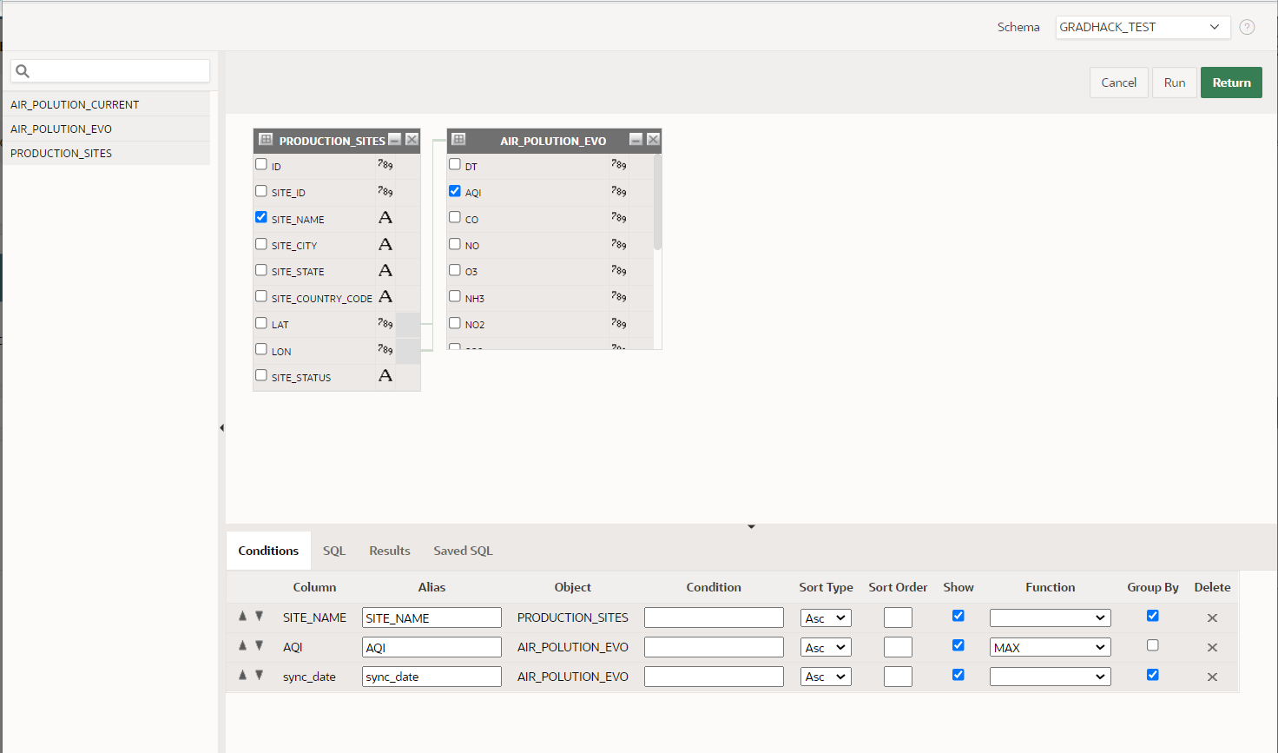
15. Click “Next”  
    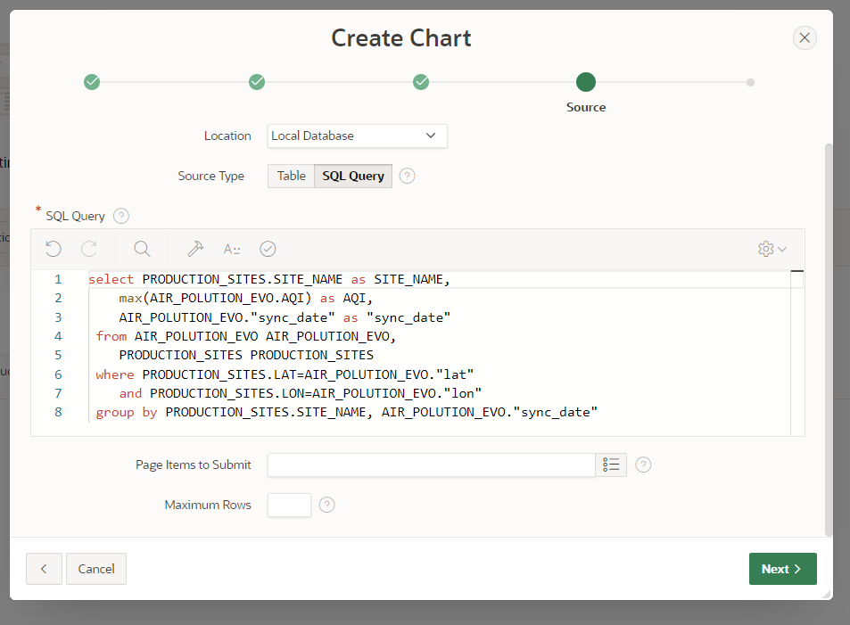
16. Choose   
    Label column: sync_date  
    Value column: AQI  
    click “Create”  
    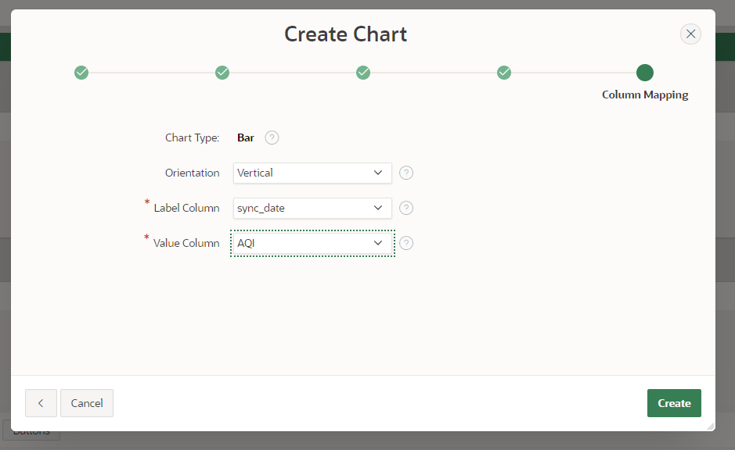
17. Click on “Series 1”  
    Change Column mapping > Series name : SITE_NAME  
    Click “Save” and “Run”  
    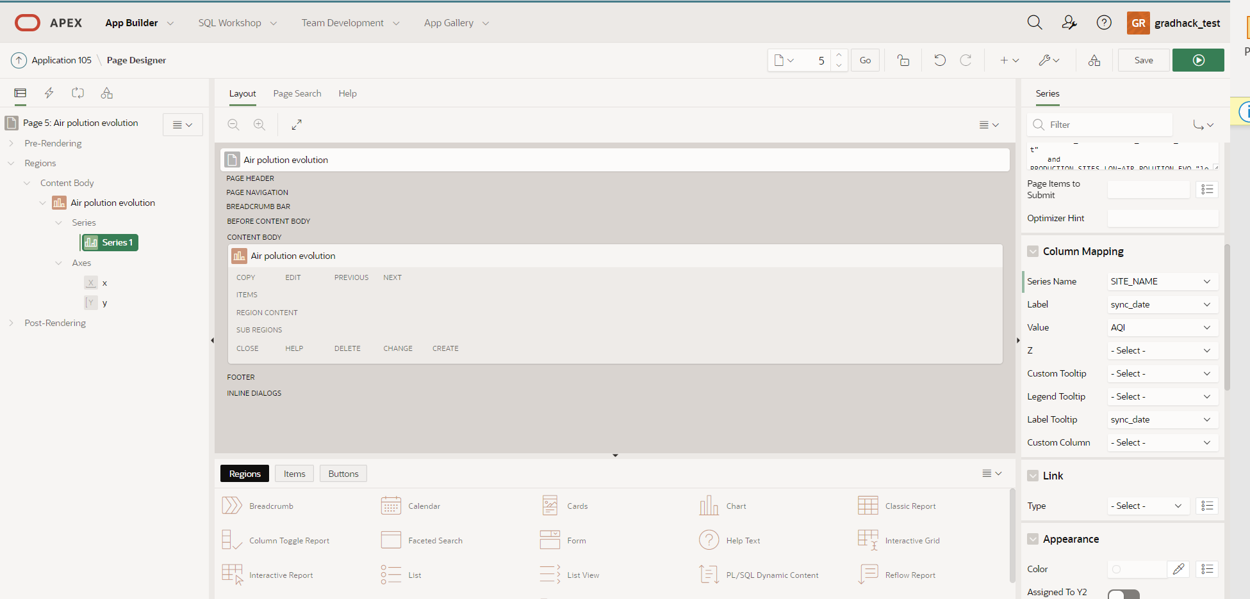
18. Your graph page will show one set of values but will grow with each synchronization  
      
    